Technical Report for ClubFactory Store

**Akshata Bhat 10541177**

**Bhakti Bidwalkar 10541969**

**Maya Sasidharan 10542633**

Contents

1. Introduction 2

1.2. Reasons for selecting the subject area and data 3

1.3. Vision and Goals 3

1.4. Key StakeHolders 4

1.5. Business requirements 4

2. SCHEMA 5

DIMENSIONS TABLES: 7

3. ETL 8

1.creating dimension tables and fact table 8

2. PRODUCT DIMENSION 10

3. Customer DIMENSION 11

4. Supplier DIMENSION 12

5. Calender DIMENSION 13

6. Fact table 14

4. VISUALIZATIONS AND REPORTS 16

5. Graph Databases 16

5.1. COMAPRISON to realtional databases 16

6. Conclusions 17

7. Bibliography 17

Appendix A – VISUALIZATIONS Code 17

Appendix B – Neo 4J code 17

# 1. Introduction

The reporting and sharing of information has been synonymous with databases as long as there have been systems to host them. Now more than ever, users expect the sharing of information in an immediate, efficient, and secure manner. However, due to the sheer number of databases within the enterprise, getting the data in an effective fashion requires a coordinated effort between the existing systems. There is a very real need today to have a single location for the storage and sharing of data that users can easily utilize to make improved business decisions.The basic objective of our project is to assess a business enterprise-ClubFactory.

A data warehouse is a collection of components and tools that retrieve data from disparate systems, transform the data and load into a database designed for analysis and reporting. A data warehouse supports coordinated reporting when companies and/or institutions upgrade or renew their information systems. Over time, it builds a historical record that can be invaluable to data scientists and business analysts. Because of these capabilities, a data warehouse can be considered an organization’s “single source of truth.”

A ware house is oriented around the major subjects of the enterprise such as customers,products,orders and suppliers. Operational applications are designed around processes and functions. The data warehouse generates a database which contains selected and aggregated information. A very large variety of data is collected, unified and updated. The information is the key for the management for better decision making. The main output from data warehouse systems are the project reports.

The data stored and used in the same is a business’s most valuable assets, as it represents much of what is known about the business, its customers,suppliers,products and orders.

## 1.2. Reasons for selecting the subject area AND DATA

In modern day,all that the world works around is business. It is the one single kind which involves greater risks and delivers greater profits. A useful statistical analysis can be done by taking numerical data that contains a different set of data from real world environment.For the most part, the benefits delivered through analyzing business include ensuring recommendations presented by technical experts conform with the needs of stakeholders and result in assessing the end users. The ClubFactory Data warehouse intends to assess the Orders, Customers, Products, Suppliers and Order Items. It is an enterprise which includes all the mentioned metrics. Business Enterprises are the most suitable for the assessment as they cover most of the operations which are expected for an ideal warehouse. The project delivery is in parts; the first part was to design and implement a data warehouse, the second part was to incorporate data quality processes into the data warehouse loading process and finally reporting on the basis of other two.

## 1.3. Vision and Goals

The ClubFactory Ware house can be implemented in any business enterprise to get all the details and reports based on the key modules,i.e, products,orders,suppliers and customers.  It provides operations to satisfy the information needs for data queries, but as general facility for getting quick, accurate and often insightful information. The design of the ware house is illustrated with the help of dimension table structures and a base star schema.

## 1.4. Key StakeHolders

Stakeholders can affect or be affected by the enterprise's actions and objectives. Some examples of key stakeholders are managers, directors, employees, owners (shareholders), suppliers, unions, and the community from which the business draws its resources.

Customers, Suppliers: EndUsers

Employee : CoreUsers

## 1.5. Business requirements

We need to keep a track of the product sales and purchase based on the location , time period and other factors to analyze the trend . This can be useful to determine the profit and loss incurred due to the ongoing process or make necessary changes as per the requirement.

# 2. SCHEMA

The objective of a data warehouse design is to create a schema that is optimized for decision support processing. The relational model is used in systems where many transactions are executed, most of them concurrently. A transaction inserts, updates or in any other way processes data in a database. In many occasions a transaction is an integral part of the business process. A Relational Database is a set of database tables that are related using keys from other database tables.

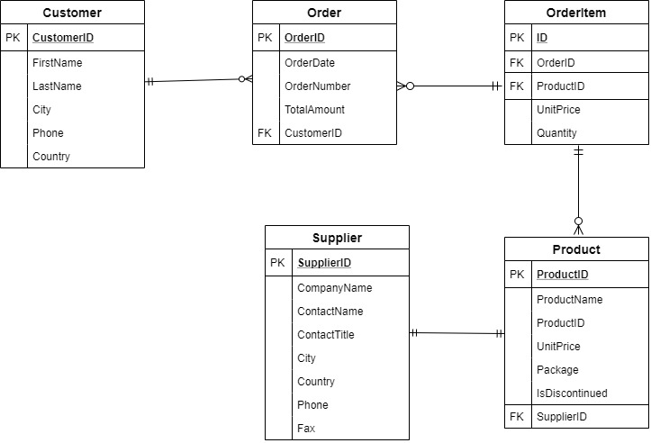

Fig. 2(a) ENTITY RELATIONSHIP DIAGRAM

Each point of data in a given data base can be split into two basic entities, namely attributes and measures. Dimensions or attributes are descriptive details about various objects allowing for their detailed analysis, measures are those that can be added across all dimensions. Measures are called facts. Facts are the reporting unit of any data warehouse, i.e. those are the ones that are manipulated, measured and reported for analysis. Dimensions are those against which these facts are reported. So it can be said that dimensions give extra information regarding the facts. A star schema consists of a central fact table which is linked directly to each of the dimension tables via a 1-1 or 1-many relationships.

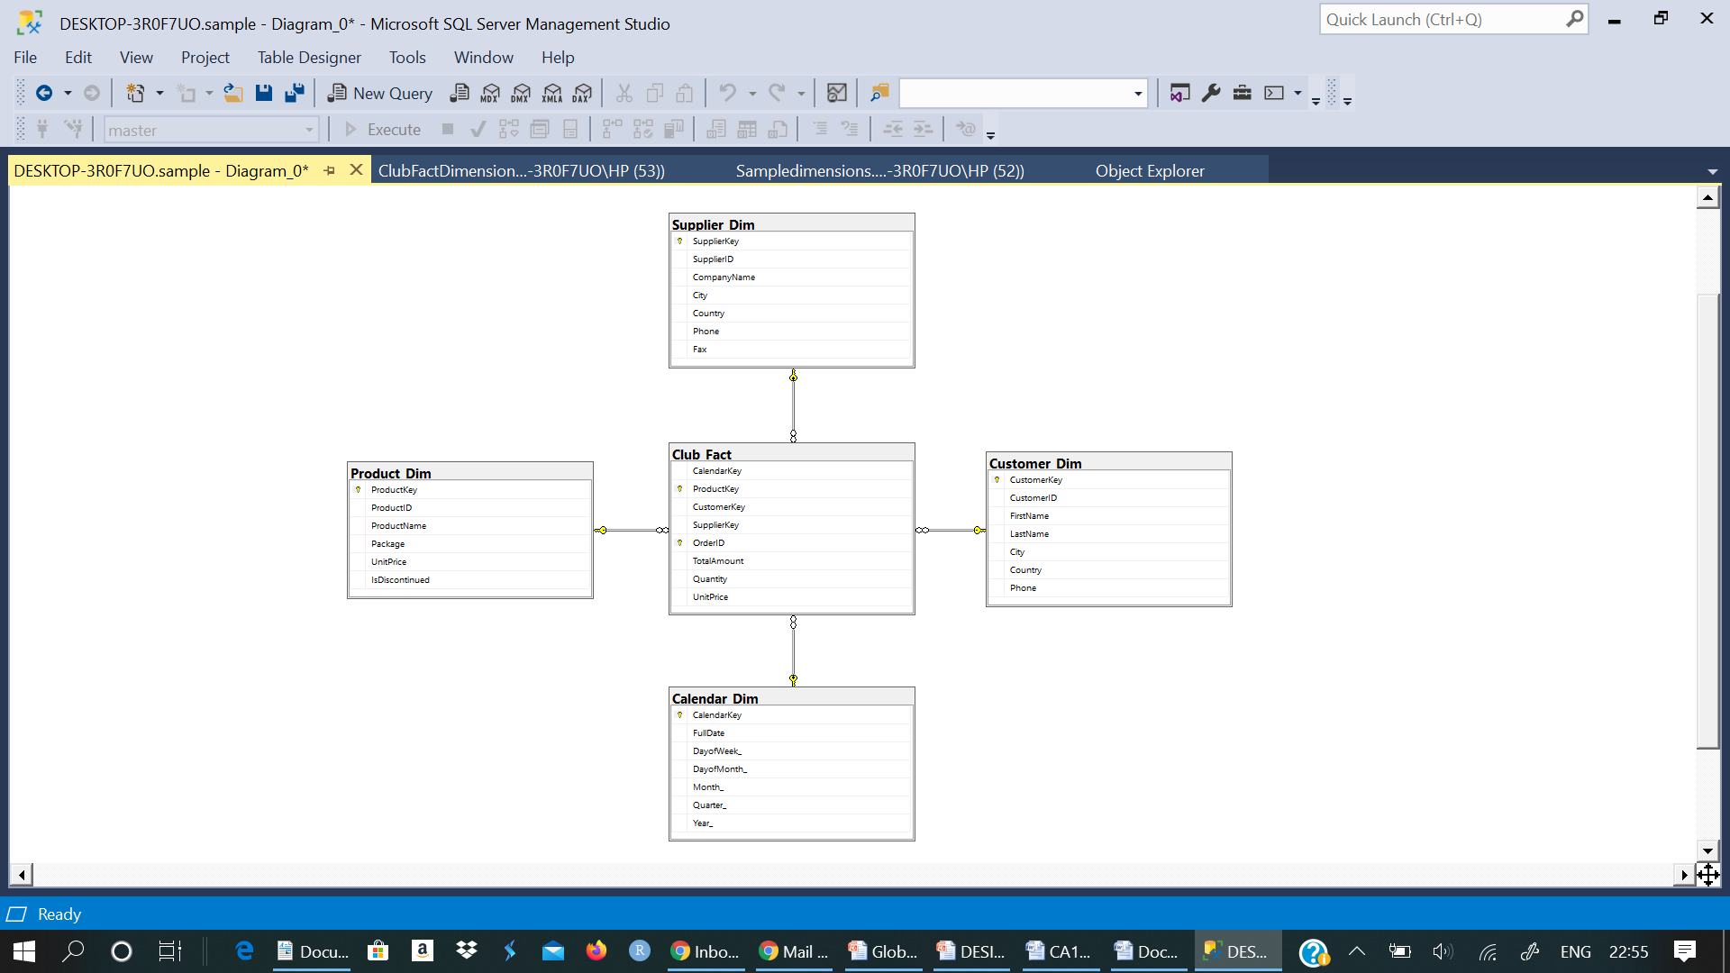

Fig. 2(b) STAR SCHEMA

## dIMENSIONS TABLES:

**Product Dimension Table:** The Product dimension table was designed by merging all Product attributes such as Name, UnitPrice. ProductKey is the Primary key.

**Customer Dimension Table:** The Customer dimension table was designed by merging all Customer attributes such as Name, City, Phone. CustomerKey is the Primary key.

**Supplier Dimension Table:** The Supplier dimension table was designed by merging all Supplier attributes such as CompanyName, City, Phone. SupplierKey is the Primary key.

**Calendar Dimension Table:** The Calendar dimension table was designed by merging all Date related attributes such as DayOfWeek, Month. CalendarKey is the Primary key.

**ClubFact Fact Table:** A facttable is the central table in a star schema of the data warehouse. It contains all the primary Keys from the Dimensions and the attributes.

# 3. ETL

Once the dimensional model is created and the fact and dimension tables are designed, there is a need to design a method to extract the data from the tables and insert/update into the dimension and fact tables. This concept of extract, transform and load is known as ETL and is the first step involved in a data warehousing application.

## creating dimension tables and fact table

USE sample

GO

CREATE TABLE Product_Dim

(

ProductKey INT NOT NULL IDENTITY,

ProductID INT,

ProductName VARCHAR(100),

Package NVARCHAR(50),

UnitPrice DECIMAL(12,2),

IsDiscontinued BIT,

PRIMARY KEY (ProductKey)

);

CREATE TABLE Customer_Dim

(

CustomerKey INT NOT NUll IDENTITY,

CustomerID INT,

FirstName NVARCHAR(40),

LastName NVARCHAR(40),

City NVARCHAR(50),

Country VARCHAR(50),

Phone NVARCHAR(20),

PRIMARY KEY (CustomerKey)

);

CREATE TABLE Supplier_Dim

(

SupplierKey INT NOT NUll IDENTITY,

SupplierID INT,

CompanyName NVARCHAR(50),

ContactTitle NVARCHAR(40),

City NVARCHAR(40),

Country VARCHAR(40),

Phone NVARCHAR(20),

Fax NVARCHAR(30),

PRIMARY KEY (SupplierKey));

GO

CREATE TABLE Calendar_Dim

(

CalendarKey INT NOT NULL IDENTITY,

FullDate varchar(50),

DayofWeek_ CHAR(15),

DayofMonth_ INT,

Month_ CHAR(15),

Quarter_ CHAR(2),

Year_ INT,

PRIMARY KEY (CalendarKey)

);

CREATE TABLE Club_Fact

(

CalendarKey INT,

ProductKey INT,

CustomerKey INT,

SupplierKey INT,

OrderID INT,

TotalAmount DECIMAL(12,2),

Quantity INT,

UnitPrice DECIMAL(12,2),

PRIMARY KEY(ProductKey, OrderID),

FOREIGN KEY (CalendarKey) REFERENCES Calendar_Dim (CalendarKey),

FOREIGN KEY (ProductKey) REFERENCES Product_Dim (ProductKey),

FOREIGN KEY (CustomerKey) REFERENCES Customer_Dim(CustomerKey),

FOREIGN KEY (SupplierKey) REFERENCES Supplier_Dim (SupplierKey)

);

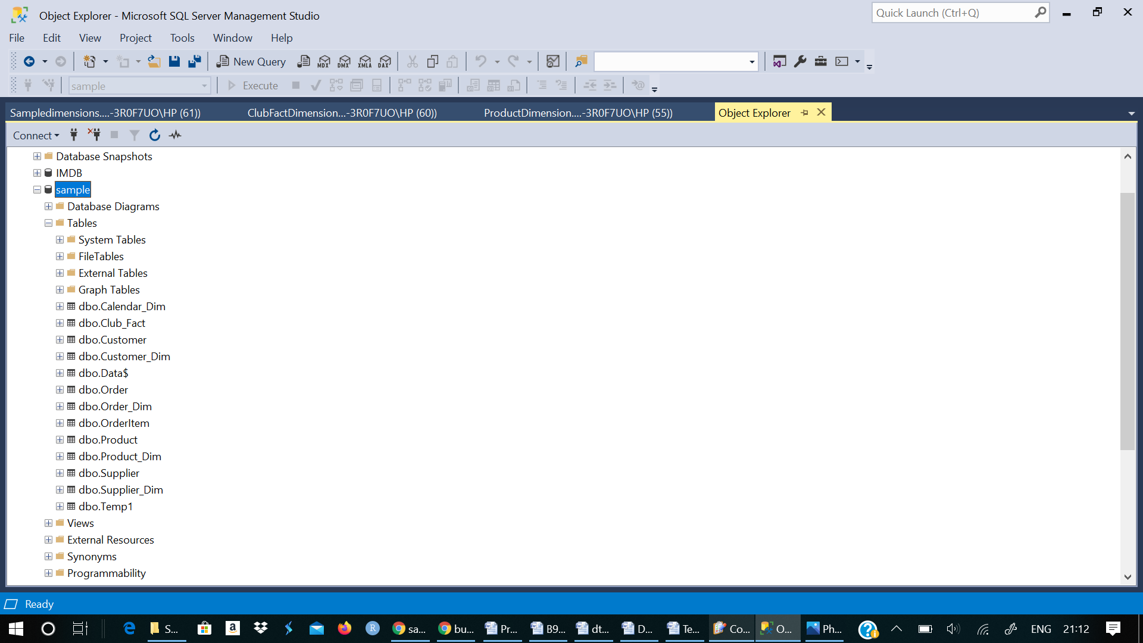

Fig. 3(a)

## 2. PRODUCT DIMENSION

INSERT INTO Product_Dim(ProductID)

SELECT ID from Product

UPDATE Product_Dim SET Product_Dim.ProductName = p.ProductName

FROM Product p INNER JOIN Product_Dim b ON b.ProductID= p.ID

UPDATE Product_Dim SET Product_Dim.UnitPrice = p.UnitPrice

FROM Product p INNER JOIN Product_Dim b ON b.ProductID= p.ID

UPDATE Product_Dim SET Product_Dim.Package = p.Package

FROM Product p INNER JOIN Product_Dim b ON b.ProductID= p.ID

UPDATE Product_Dim SET Product_Dim.IsDiscontinued = p.IsDiscontinued

FROM Product p INNER JOIN Product_Dim b ON b.ProductID= p.ID

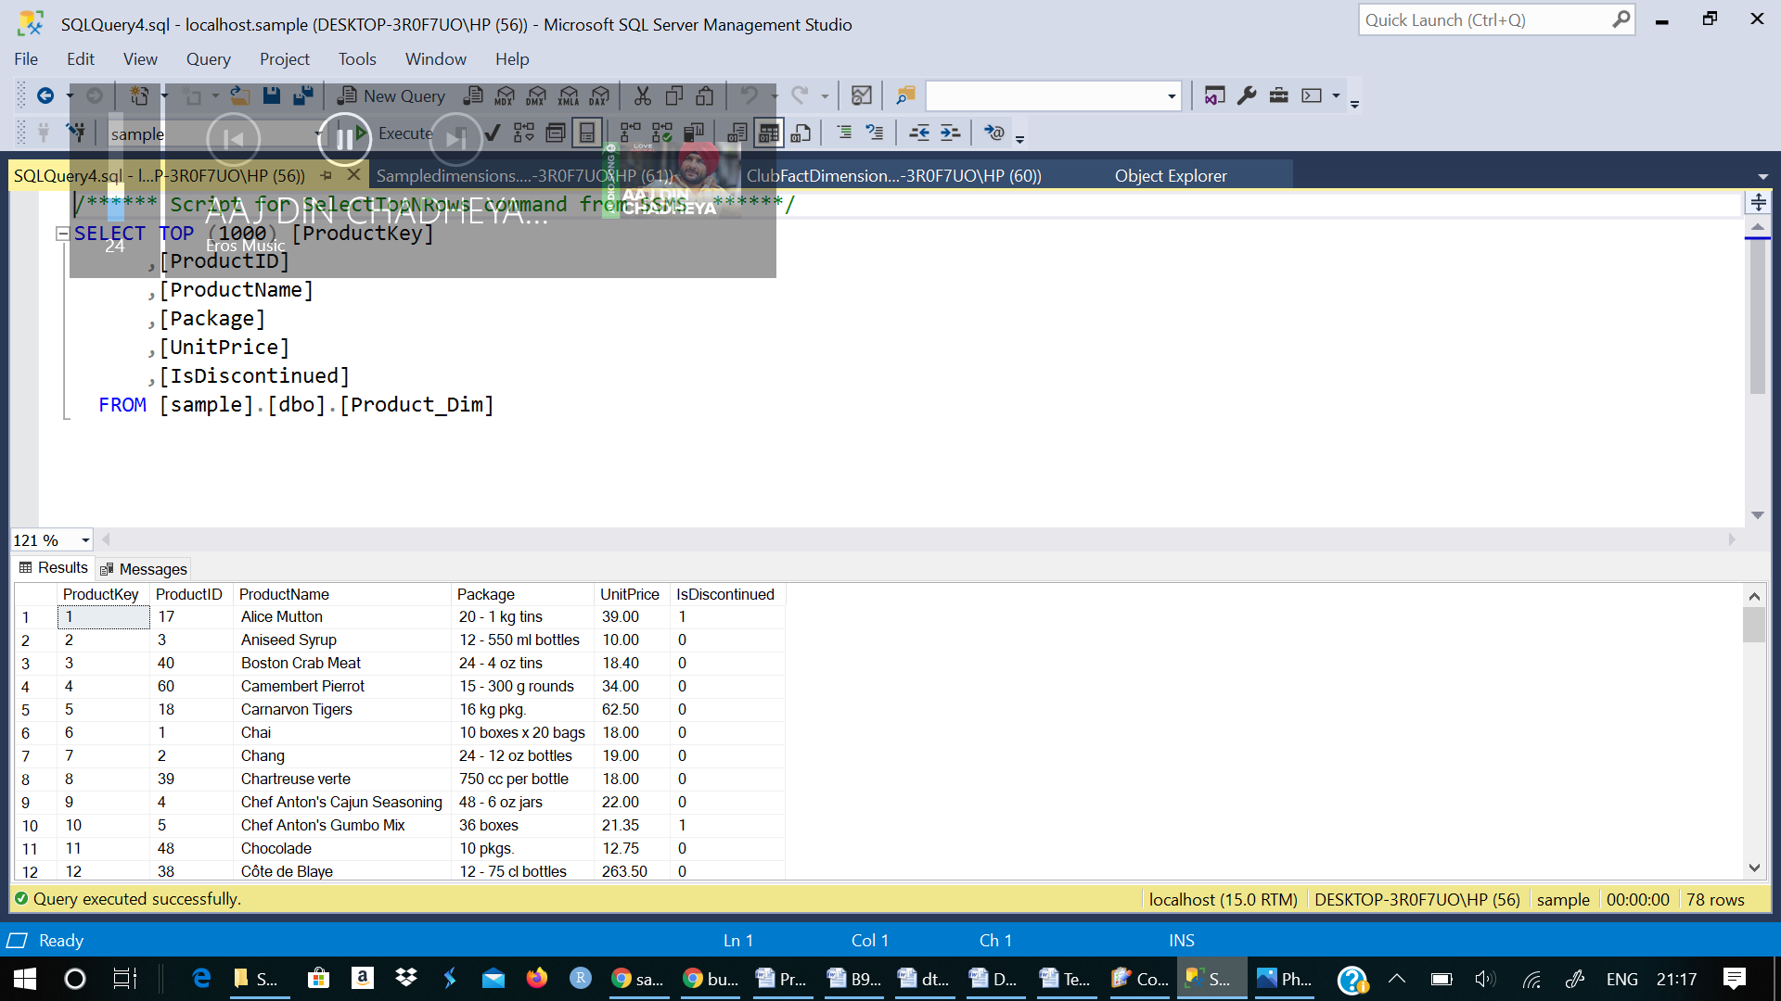Fig. 3(b)

## 3. Customer DIMENSION

INSERT INTO Customer_Dim(CustomerID)

SELECT ID from Customer

UPDATE Customer_Dim SET Customer_Dim.FirstName = c.FirstName

FROM Customer c INNER JOIN Customer_Dim a ON a.CustomerID= c.ID

UPDATE Customer_Dim SET Customer_Dim.LastName = c.LastName

FROM Customer c INNER JOIN Customer_Dim a ON a.CustomerID= c.ID

UPDATE Customer_Dim SET Customer_Dim.City = c.City

FROM Customer c INNER JOIN Customer_Dim a ON a.CustomerID= c.ID

UPDATE Customer_Dim SET Customer_Dim.Country = c.Country

FROM Customer c INNER JOIN Customer_Dim a ON a.CustomerID= c.ID

UPDATE Customer_Dim SET Customer_Dim.Phone = c.Phone

FROM Customer c INNER JOIN Customer_Dim a ON a.CustomerID= c.ID

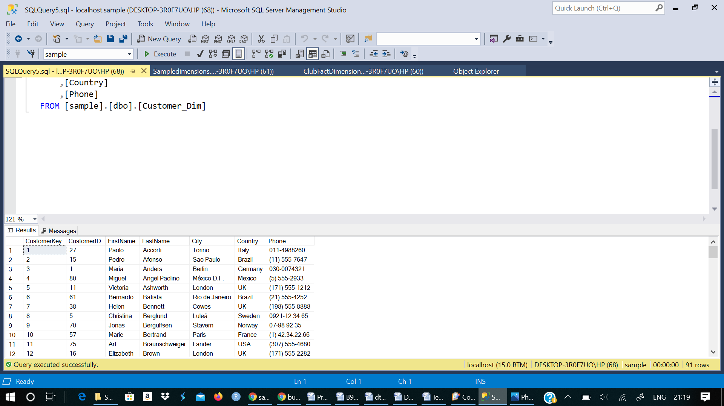

Fig. 3(c)

## 4. Supplier DIMENSION

INSERT INTO Supplier_Dim(SupplierID)

SELECT ID from Supplier

UPDATE Supplier_Dim SET Supplier_Dim.CompanyName = s.CompanyName

FROM Supplier s INNER JOIN Supplier_Dim c ON c.SupplierID= s.ID

UPDATE Supplier_Dim SET Supplier_Dim.City = s.City

FROM Supplier s INNER JOIN Supplier_Dim c ON c.SupplierID= s.ID

UPDATE Supplier_Dim SET Supplier_Dim.Country = s.Country

FROM Supplier s INNER JOIN Supplier_Dim c ON c.SupplierID= s.ID

UPDATE Supplier_Dim SET Supplier_Dim.Phone = s.Phone

FROM Supplier s INNER JOIN Supplier_Dim c ON c.SupplierID= s.ID

UPDATE Supplier_Dim SET Supplier_Dim.Fax = s.Fax

FROM Supplier s INNER JOIN Supplier_Dim c ON c.SupplierID= s.ID

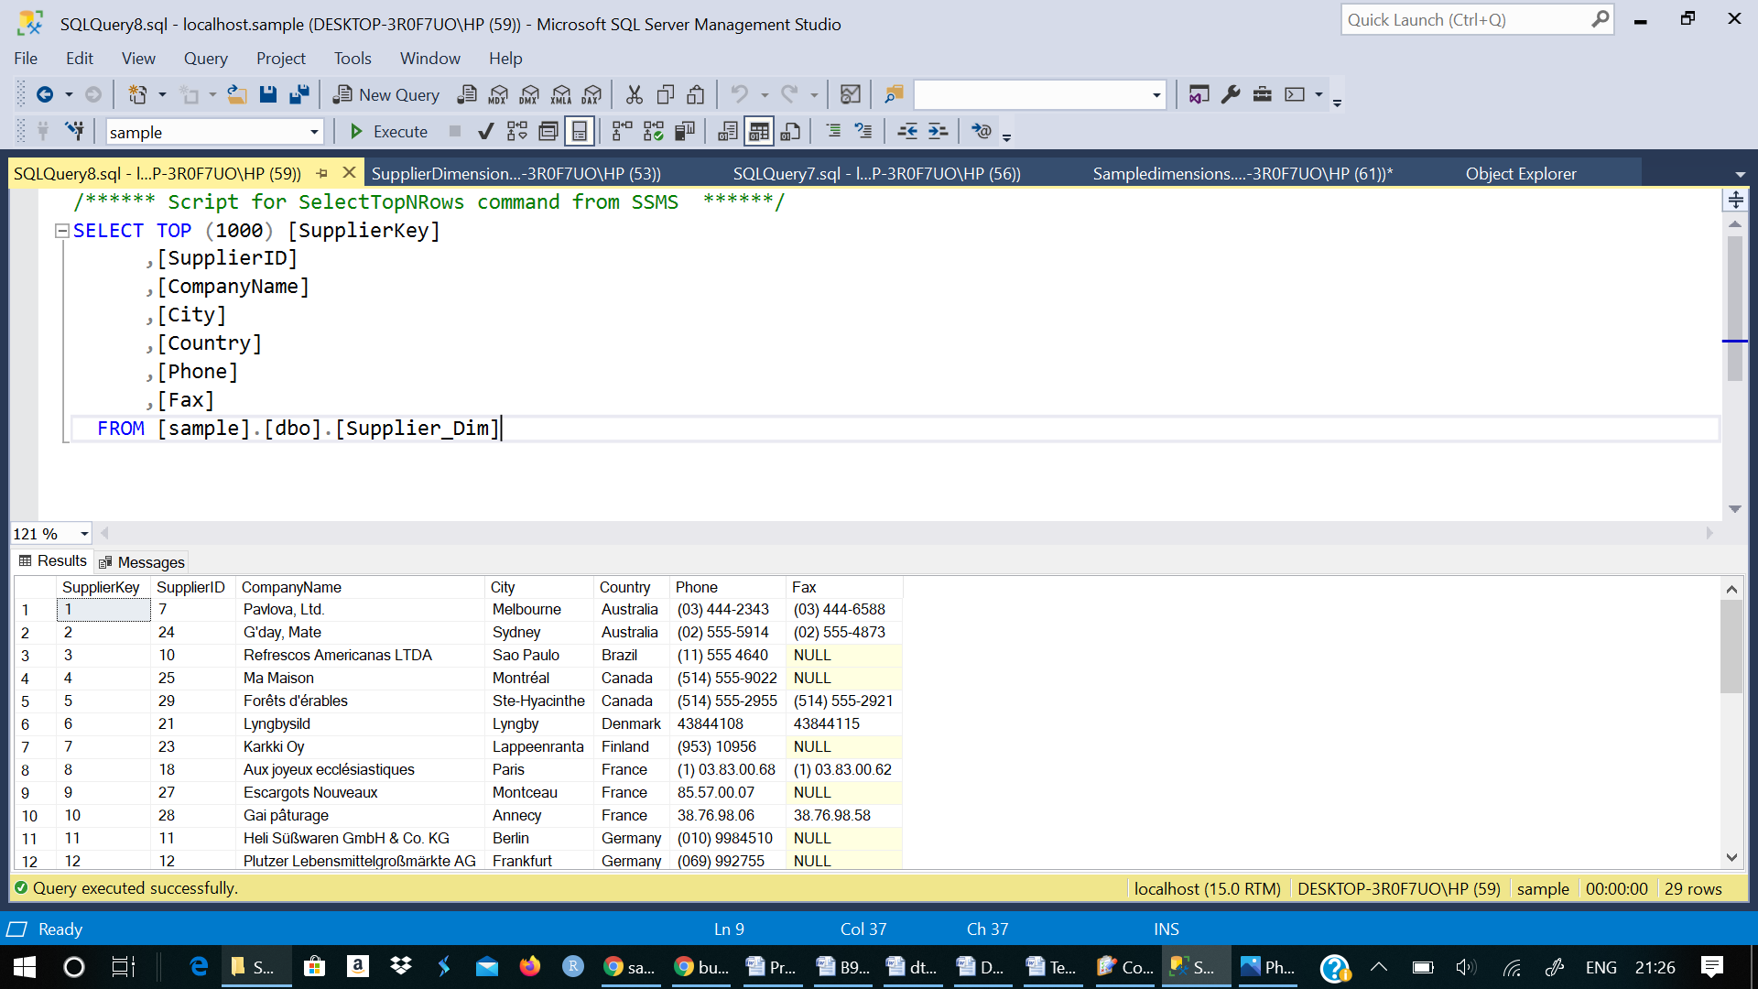

Fig 3(d)

## 5. Calender DIMENSION

INSERT INTO Calendar_Dim(FullDate, DayofWeek_,

DayofMonth_, Month_, Quarter_, Year_)

SELECT DISTINCT d.OrderDate, DATENAME(dw, d.OrderDate),DATEPART(day,d.OrderDate),

DATEPART(month, d.OrderDate),CONCAT('Q',DATEPART(q, d.OrderDate)),

DATEPART(yyyy, d.OrderDate)

FROM "Order" d

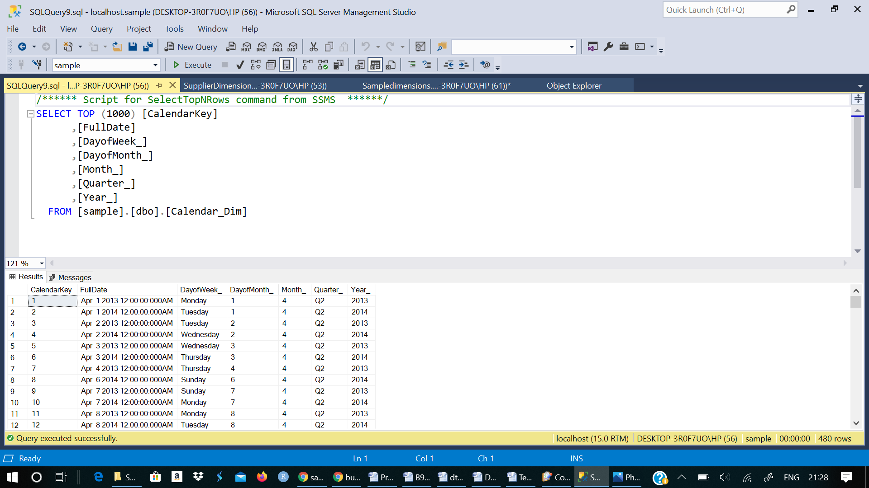Fig 3(e)

## 6. Fact table

CREATE TABLE Temp1(

CalendarKey int,

ProductKey int,

CustomerKey int,

SupplierKey int,

ProductId int,

CustomerId int,

SupplierId int,

OrderID int,

OrderDate varchar(50),

TotalAmount decimal(12,2),

Quantity INT,

UnitPrice decimal(12,2)

)

INSERT INTO Temp1(ProductId,CustomerId,OrderId, SupplierID, OrderDate,TotalAmount,Quantity,UnitPrice)

SELECT p.ID,c.ID,o.ID,s.Id, o.OrderDate,o.TotalAmount,d.Quantity,p.UnitPrice

FROM Product p, Customer c, OrderItem d, "Order" o, Supplier s

Where d.ProductID = p.ID and o.CustomerID = c.ID and d.OrderID = o.ID and s.Id= p.SupplierId

UPDATE Temp1 SET Temp1.SupplierKey = s.SupplierKey

from Supplier_Dim s Inner join Temp1 t on s.SupplierID = t.SupplierID

go

UPDATE Temp1 SET Temp1.ProductKey = p.ProductKey

from Product_Dim p Inner join Temp1 t on p.ProductID = t.ProductId

UPDATE Temp1 SET Temp1.CustomerKey = p.CustomerKey from Customer_Dim p Inner Join Temp1 t on t.CustomerId = p.CustomerID

UPDATE Temp1 SET Temp1.CalendarKey = p.CalendarKey from Calendar_Dim p Inner Join Temp1 t on t.OrderDate = p.FullDate

Insert into Club_Fact(CalendarKey,ProductKey,CustomerKey,SupplierKey,OrderID,TotalAmount,Quantity,UnitPrice)

SELECTCalendarKey,ProductKey,CustomerKey,SupplierKey,OrderID,TotalAmount,Quantity,UnitPrice FROM Temp1

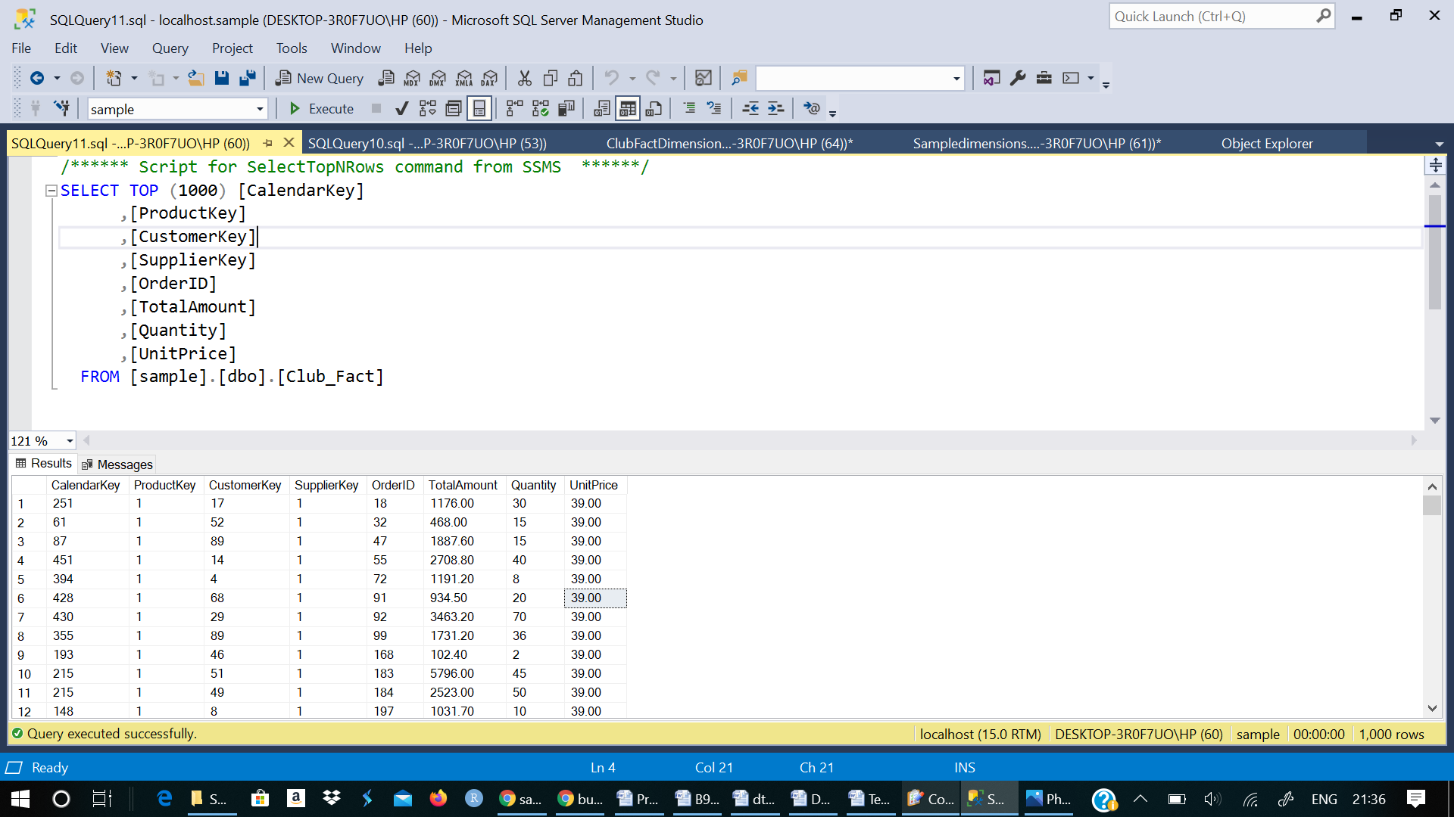

Fig 3(f)

# 4. VISUALIZATIONS AND REPORTS

## 4.1. Visualizations

In order to perform an analysis, we generate reports that will be able to predict the sales and inventory analysis

**Report 1 : Top 10 Products Sold**

In this report we analyze the highest selling product based on the the total amount and filter out the top 10 values .

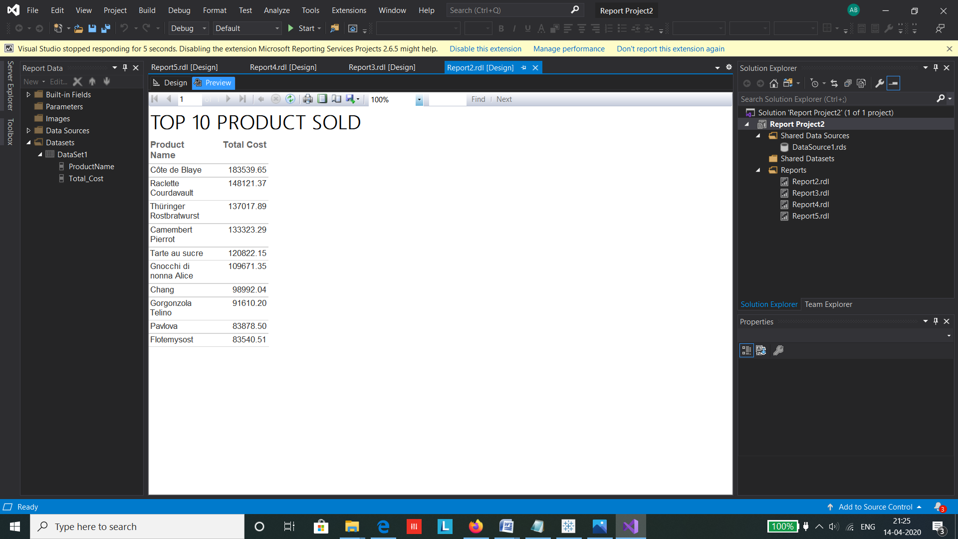

This will help in analyzing the products that are highest in demand and help in the business growth.

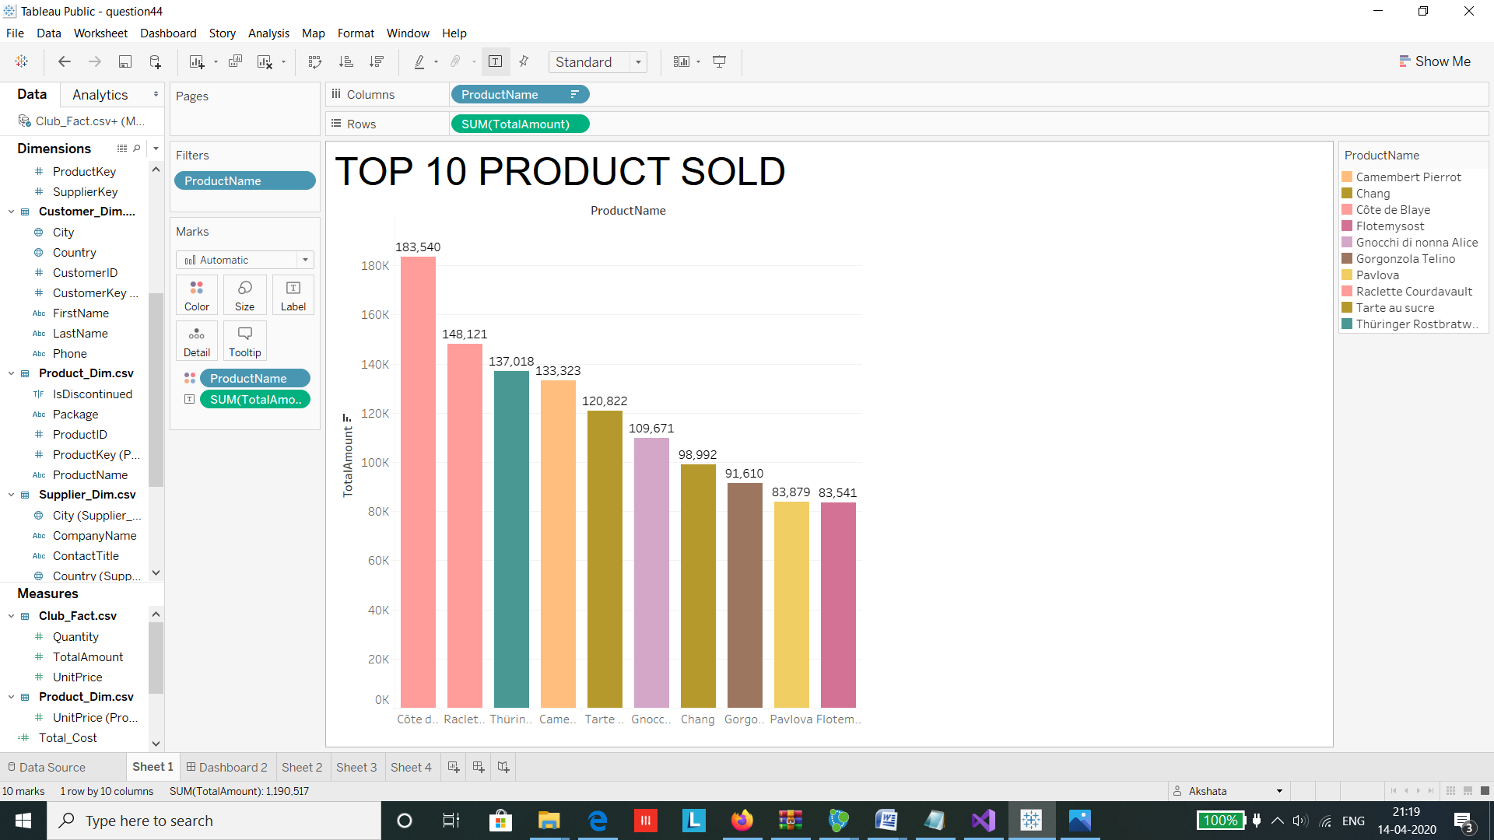

**Report 2 : Countrywise Sales for Product Alice Meat**

In this report we analyze the sales for the selected product named Alice Meat according to its country-wise distribution by joining of the product and customer dimensions .

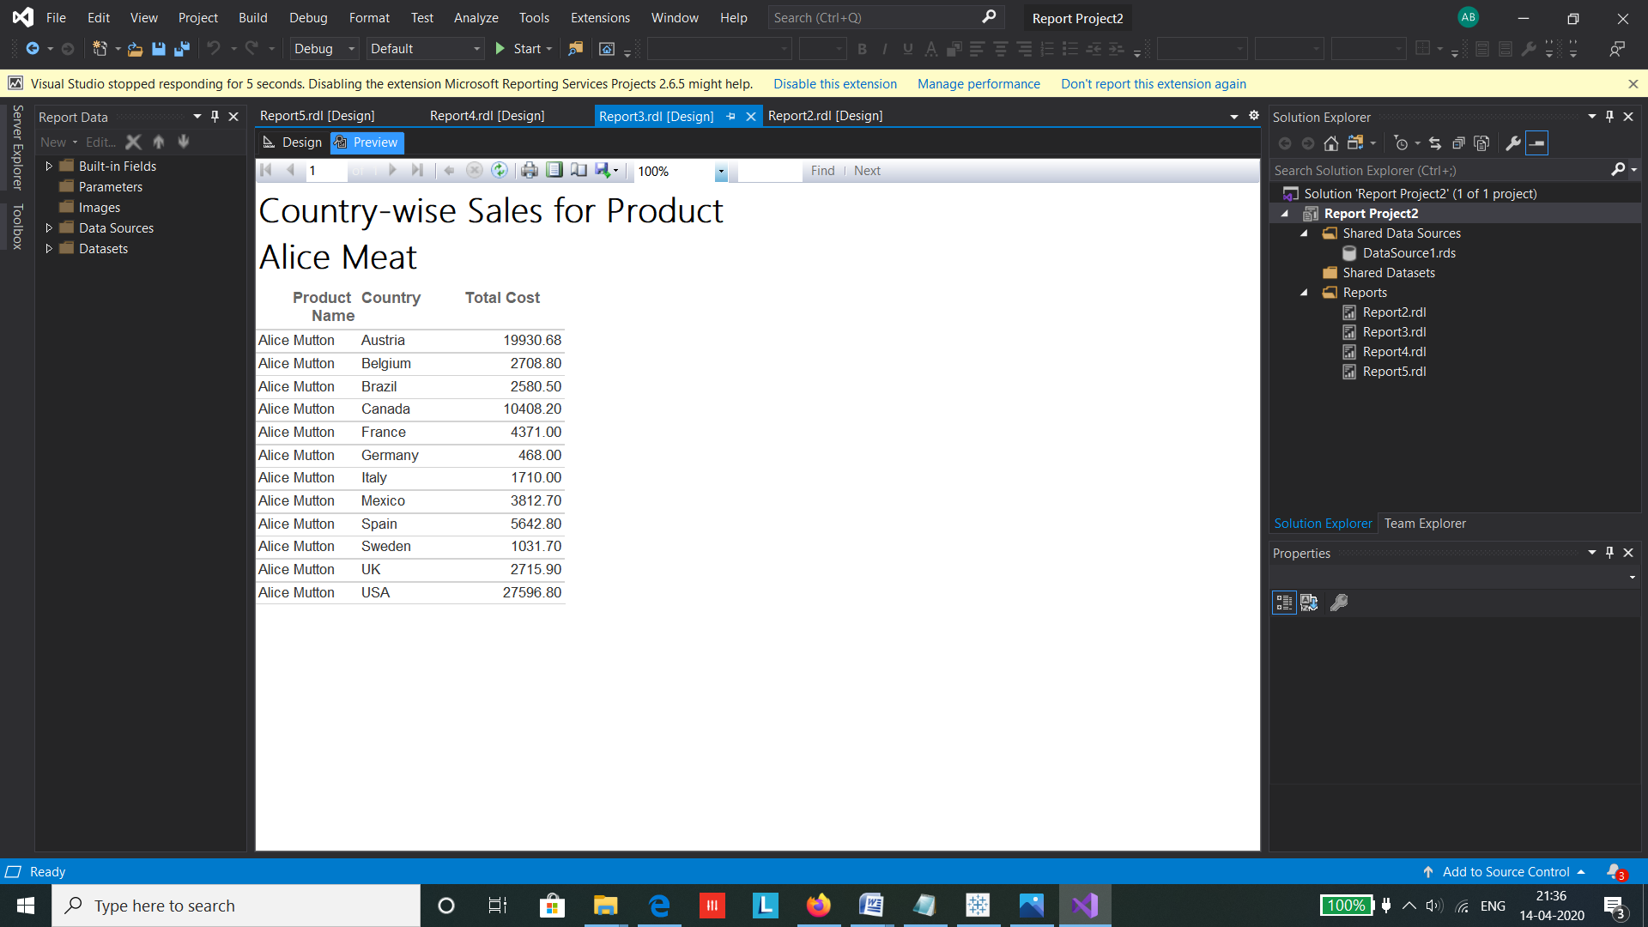

Such analysis can be useful to predict region wise sales and find out the location where the sales are high in order to implement marketing stratergies.

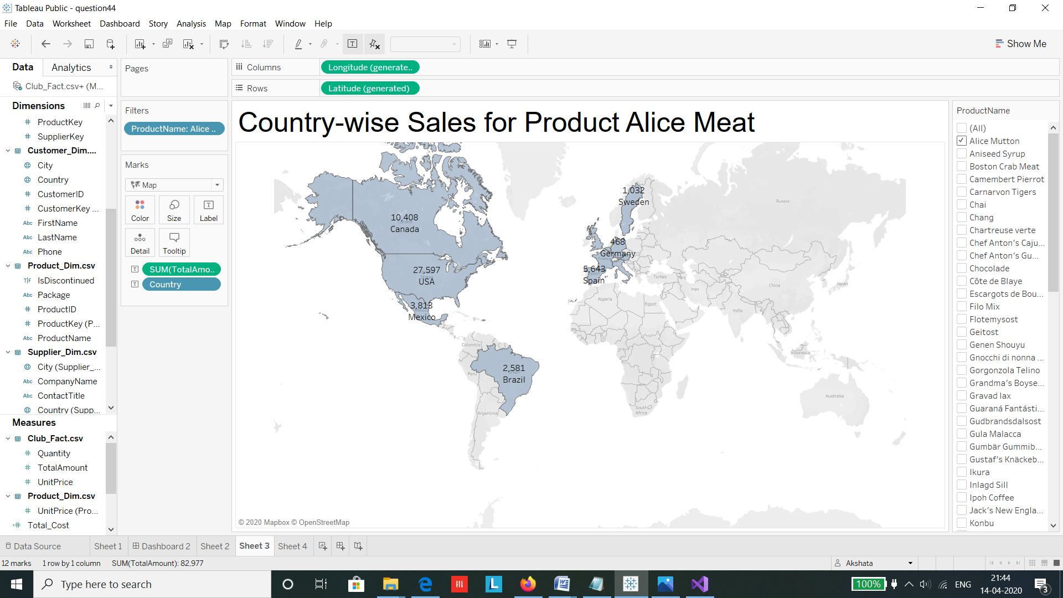

**Report 3 : Product Chai’s Monthly Inventory**

It is necessary to analyze the inventory stocks in order to avoid unnecessary expenditures due to over stocking or running out of stocks. Here we are analyzing the quantity of product Chai, over monthly time period .

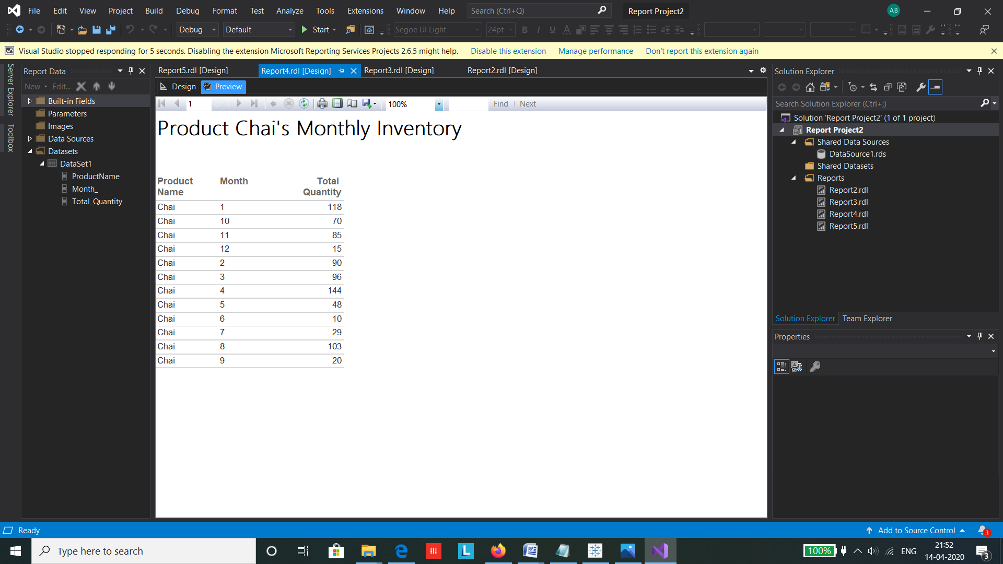

The visual representation gives a clear monthly analysis of quantity present in the inventory which gives an estimate that during the month of June the quantity of Chai was lowest this could be due to high demands of the product.

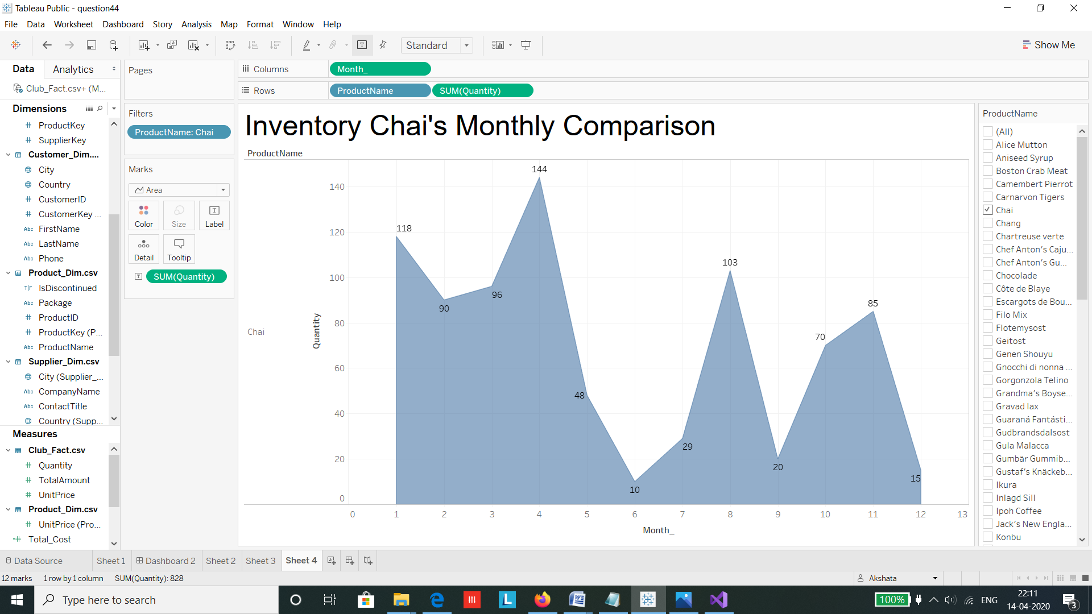

**Report 4 : Inventory Value Comparison**

It is necessary to know which product has a high inventory value in order to keep a track of which product needs more marketing to be sold.

Here we have used a field Product value which is created by multiplying the quantity of the product with its respective unit price. 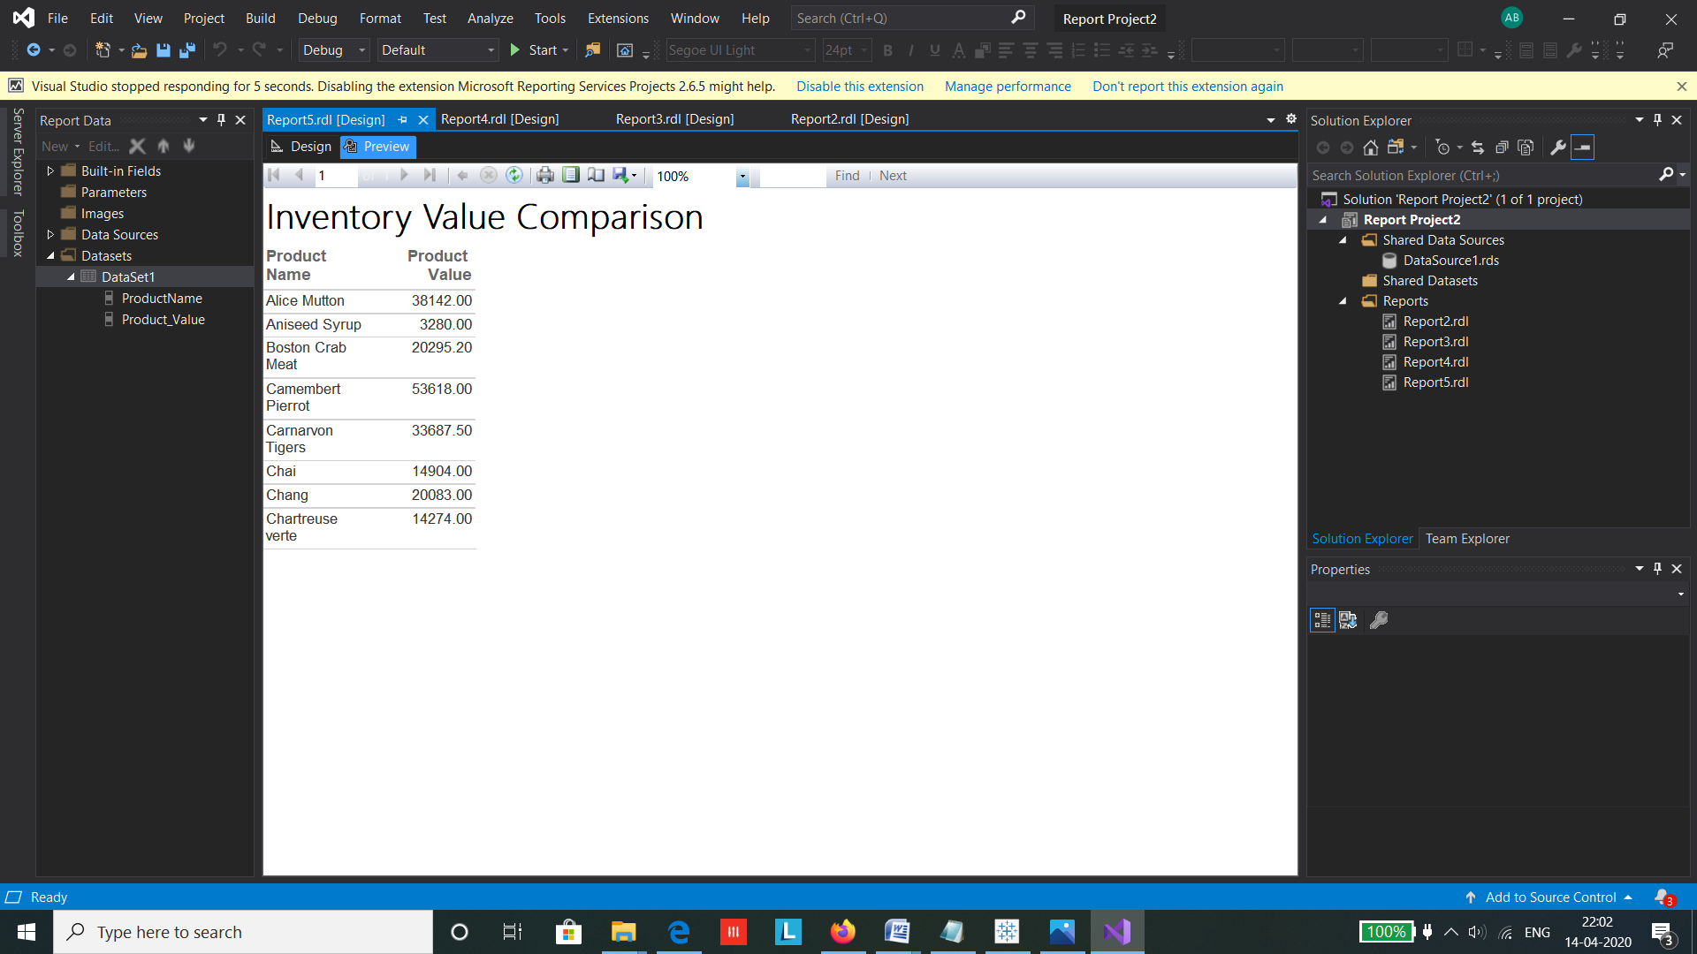

For analysis we have applied filter on certain products to get a detailed comparison between the selected few products.

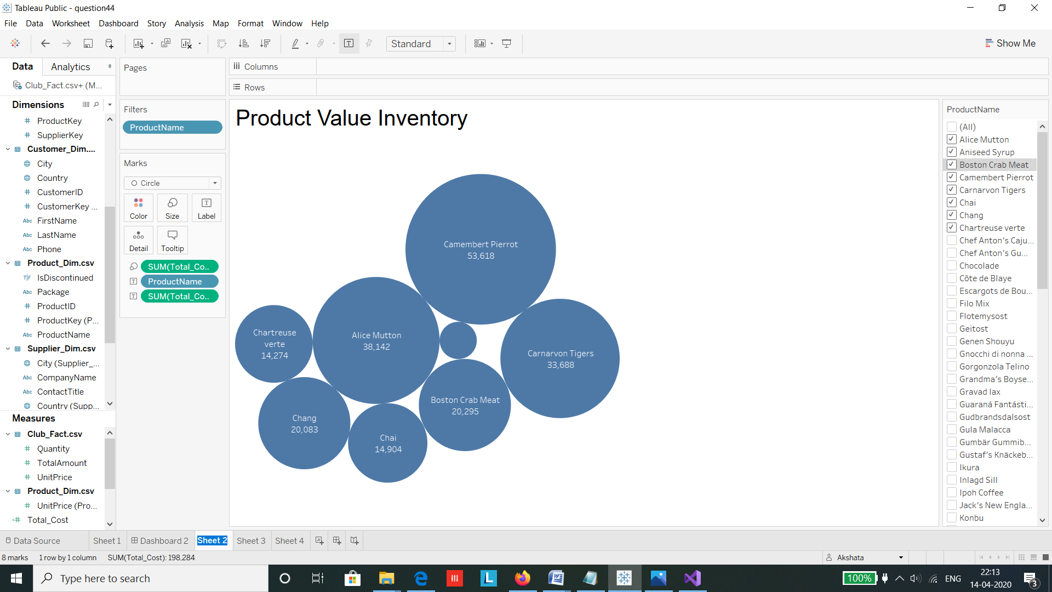

We create a dashboard to compare the visualizations side by side . It helps in getting an quick overview of the business , not only by the core users but also the non technical users involved in the business.

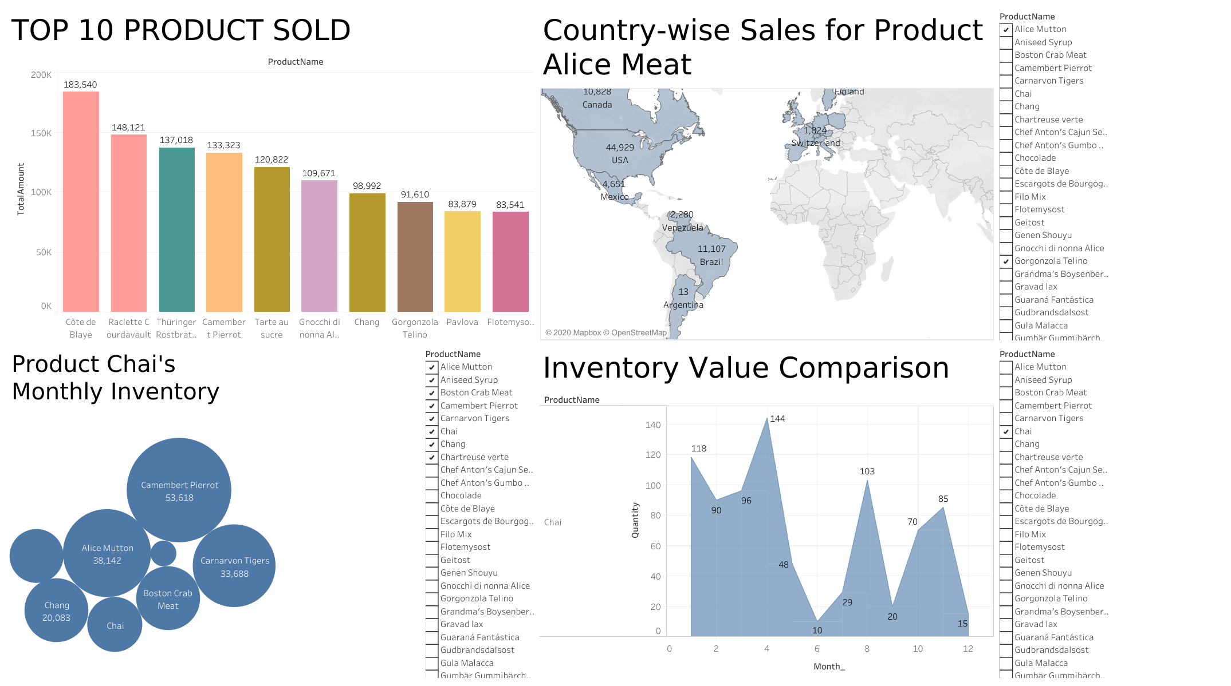

See Appendix A for SSRS codes

# 5. Graph Databases

We use Neo4j’s Cypher Query Language to compare our relational database models.

First step involves Creating the Adventure Works model into the database and populating them

In Neo4j, nodes represent each entity having attributes and a relationship can be established between these nodes to connect the nodes.

These are the nodes and relationships created for our AdventureWorks database.

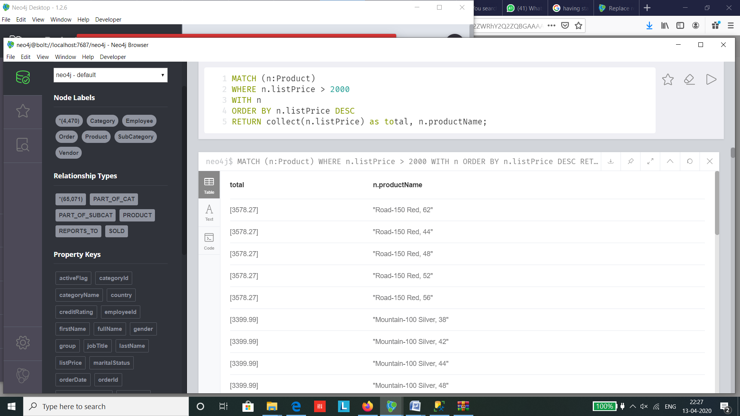

We can click on each of the nodes as well as the relationships to check its graphical representation .

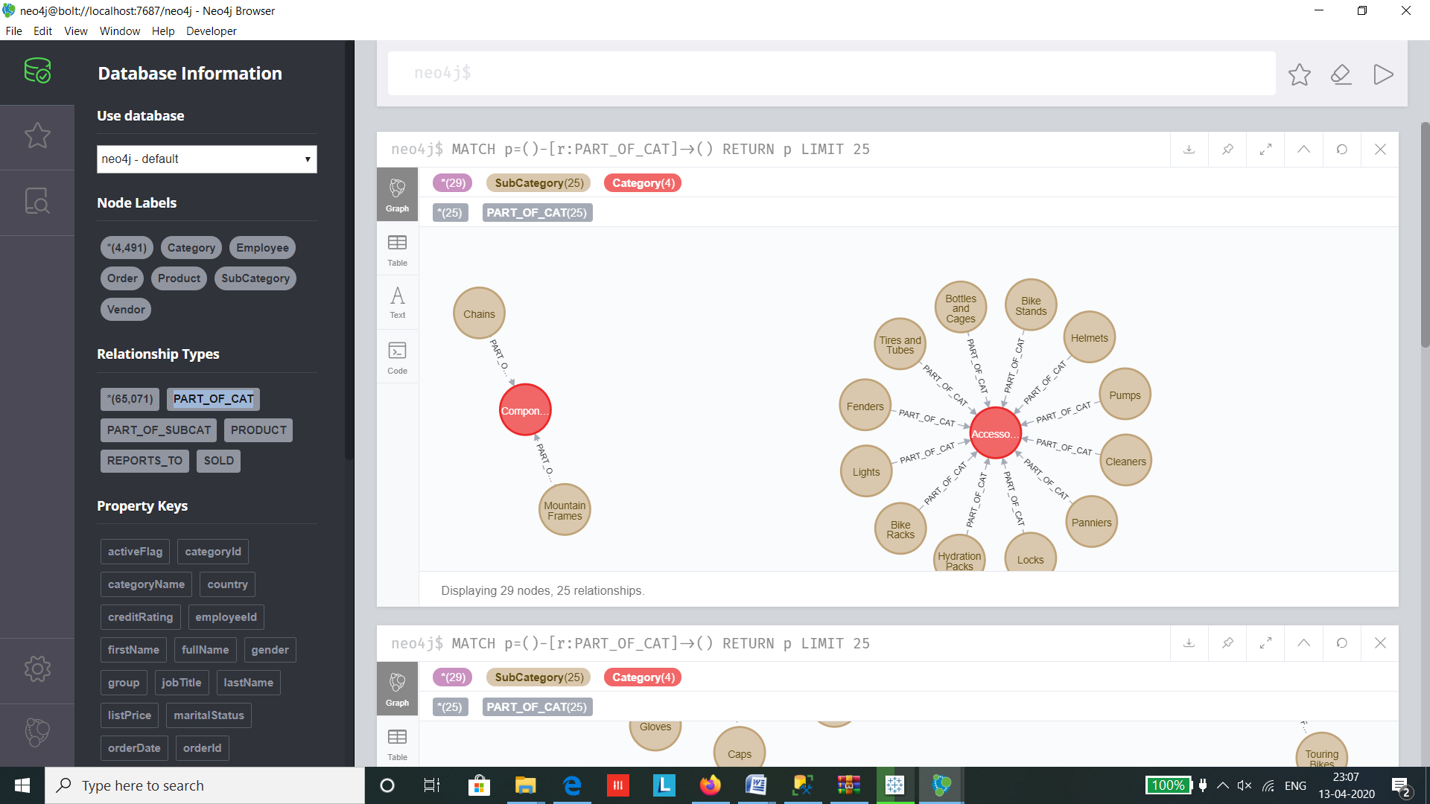

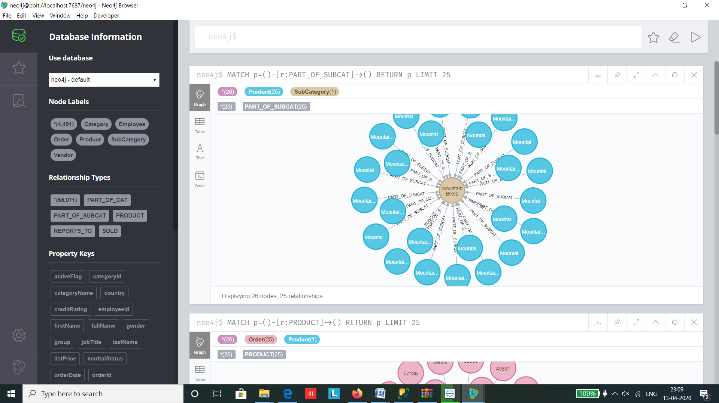

**Query 1 : To read values**

1) In SQL to read a value from the table we use the SELECT statement followed by the table name from which we want to read the data.

Here we perform simple query to read the types of Category present in the Product Category table

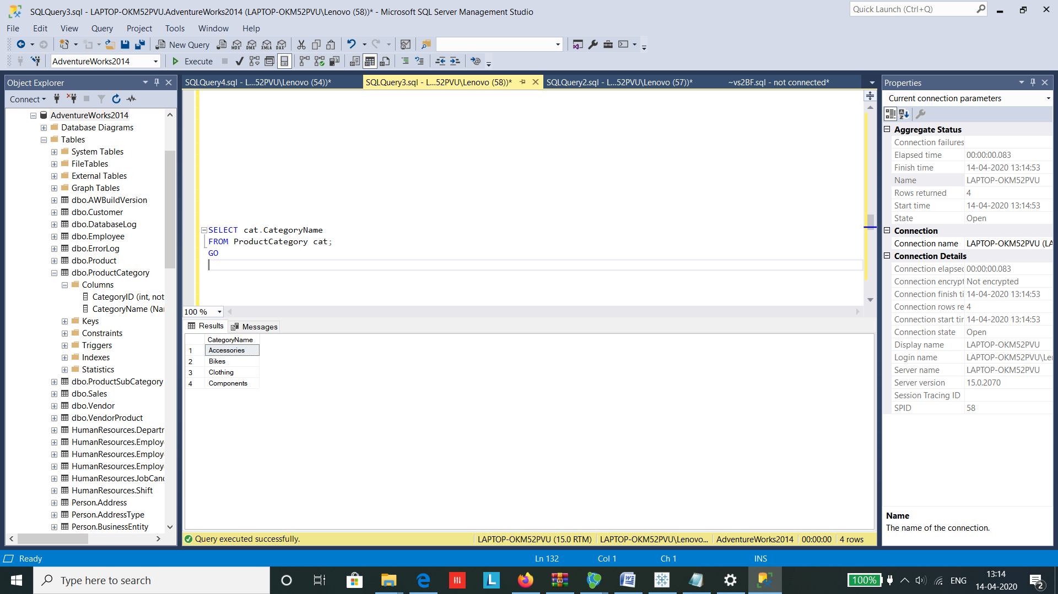

Incase of CQL, the MATCH statement is used to find similar pattern to the value of category. Once the pattern is found just like the SELECT statement in SQL , the RETURN statement in CQL is used.

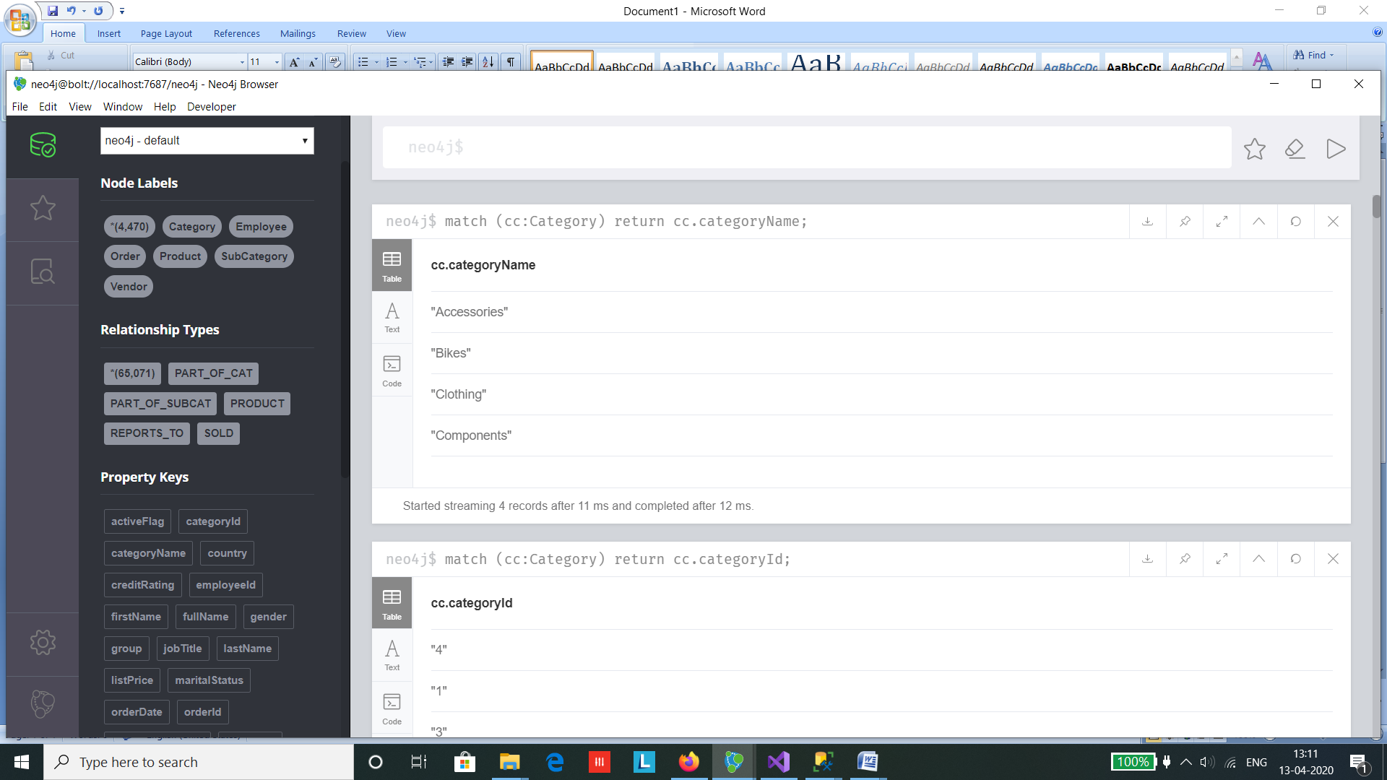

**Query 2 : Filtering the values**

For filtering the data we use the WHERE statement which is similar in both SQL and CQL .

But notice the difference in the placement of the where statement.

The filter condition to find the employee with first name ‘Stephen’ is applied after the employee values are retrieved from the Employeee Table.

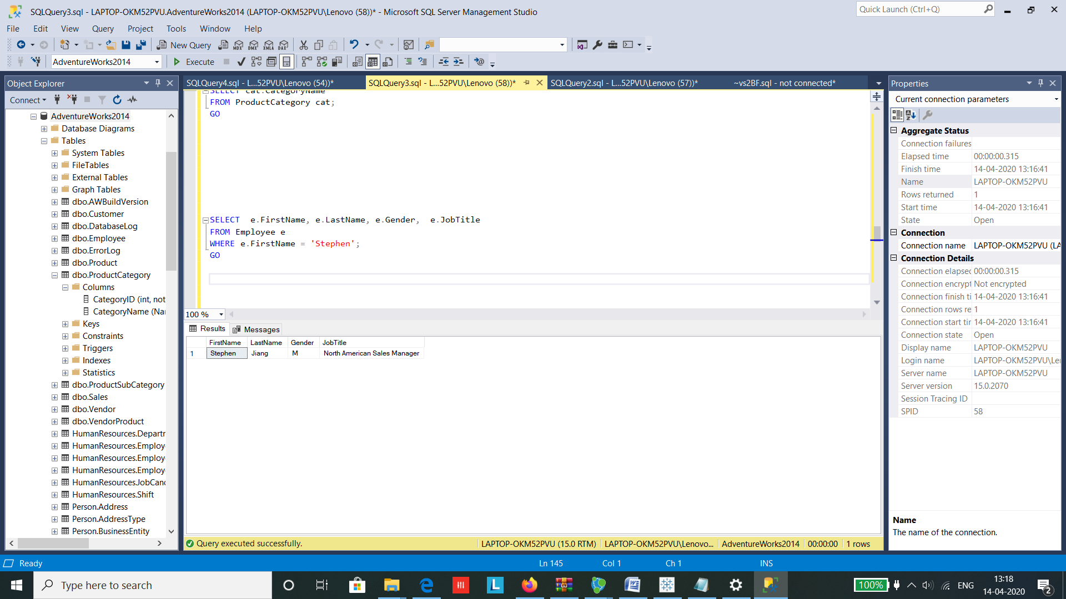

The filter condition to find the first name ‘Stephen’ is applied after the Employee pattern is matched to the node and then the values are retrieved.

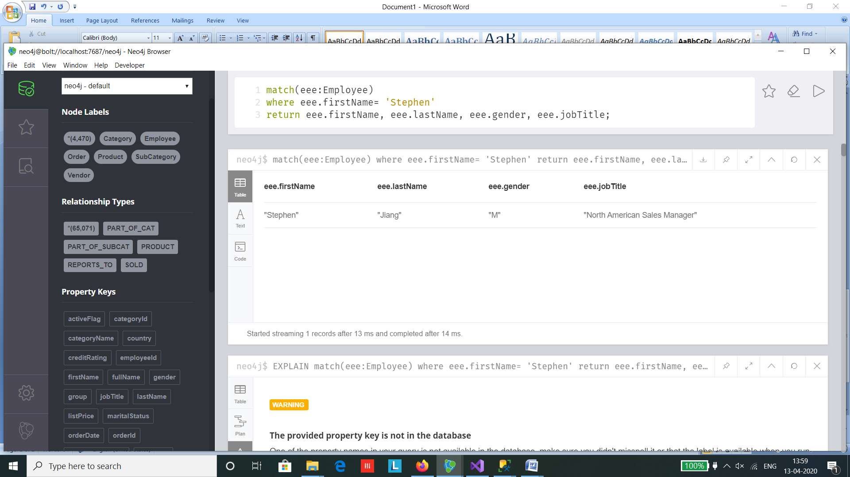

**Query 3 : Join Query**

We will apply a query to find the Product Name , Product Category and Product Subcategory for the subcategory named ‘Brakes’ .

To achieve this in SQL we apply Join on the Product table, Category and Subcategory tables on their respective Ids.

Since SubCategory contains CategoryKey and the Product table contains the SubcategoryKey we choose SubCategory as our primary table.

The JOIN statement acheieves a relation between the tables.

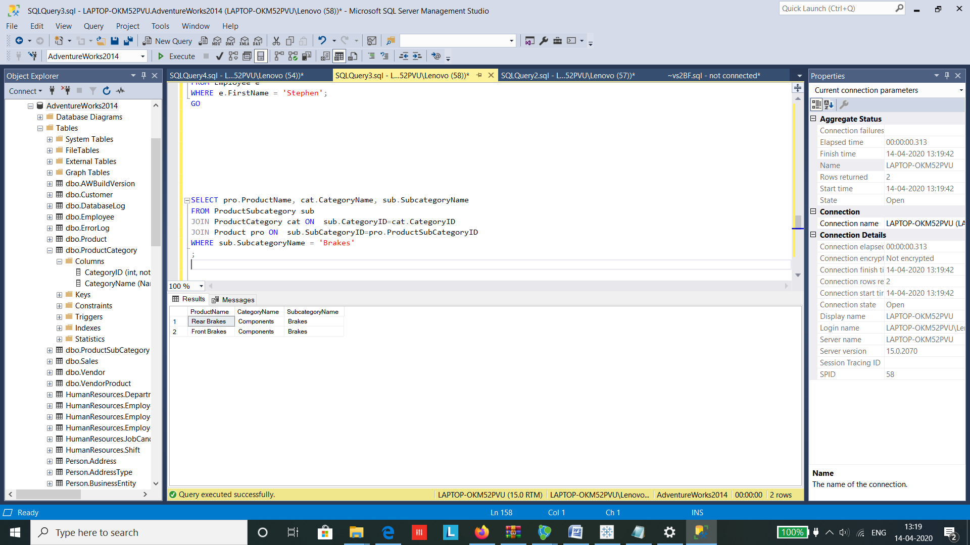

In case of SQL a relationship is established between each nodes which is used to connect the nodes to each other denoted by 🡪 which is a directed relationship while **-** denotes an undirected relationship . A relationship needs to be created before hand using the following query while creating the tables

*MERGE (subcategory)-[:PART_OF_CAT]->(category);*

*MERGE (product)-[:PART_OF_SUBCAT]->(subcategory);*

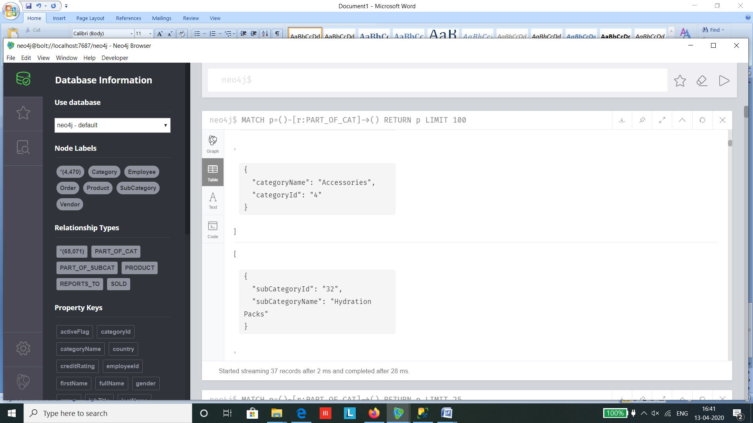

Since subcategory connects both the product and category tables we type the following query :

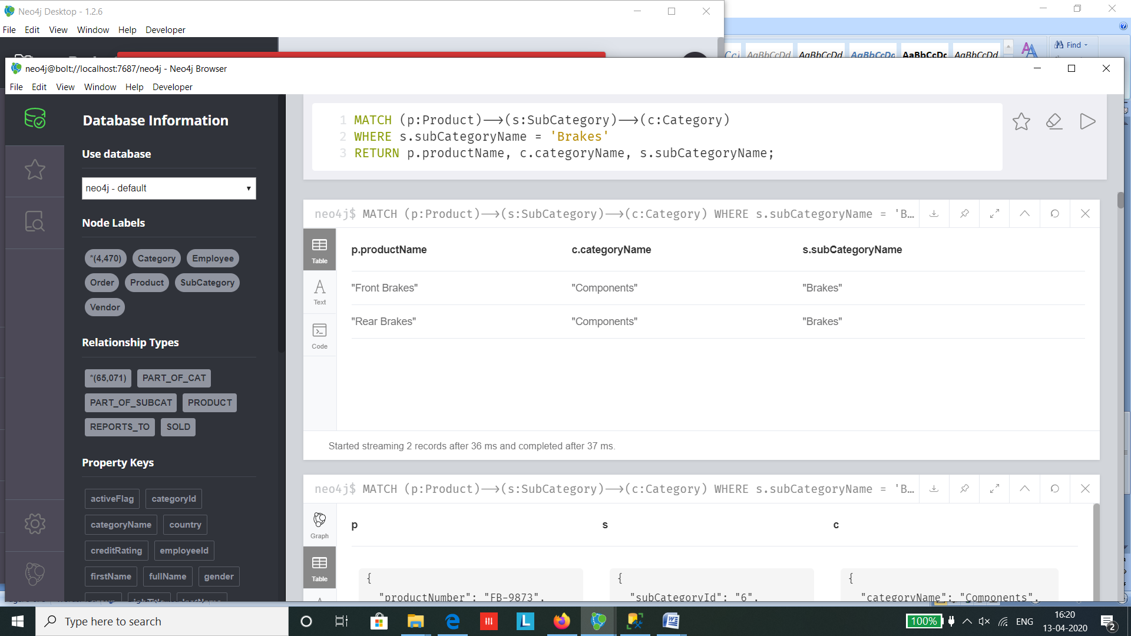

**Query 4 : Type Casting**

The ALTER statement is used to change the datatype of a column in SQL. Here we have changed the datatype of ListPrice to Float

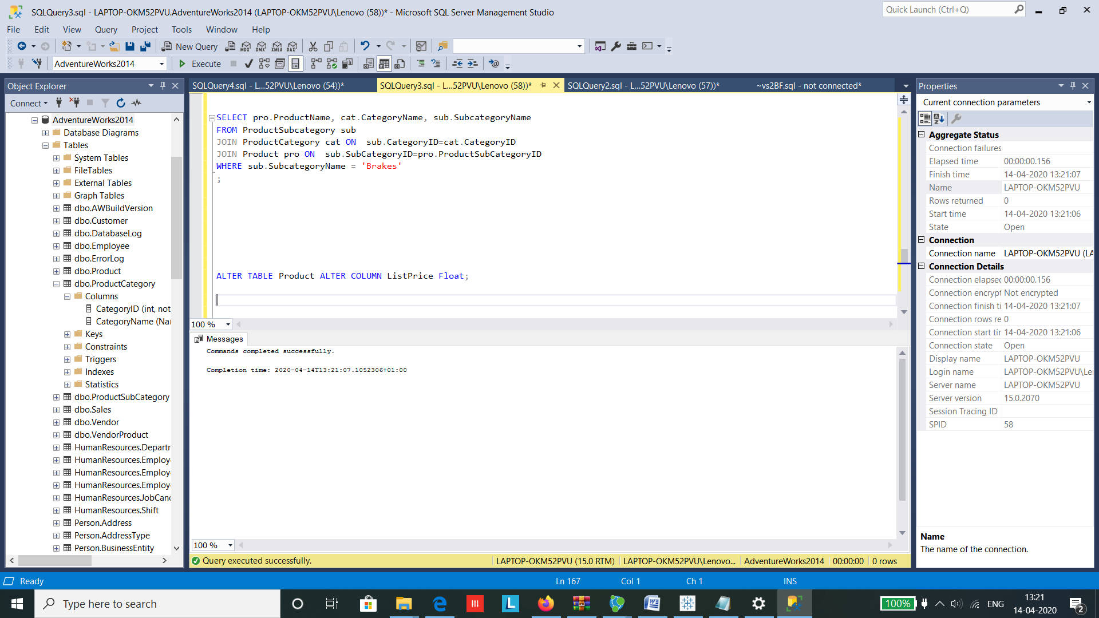

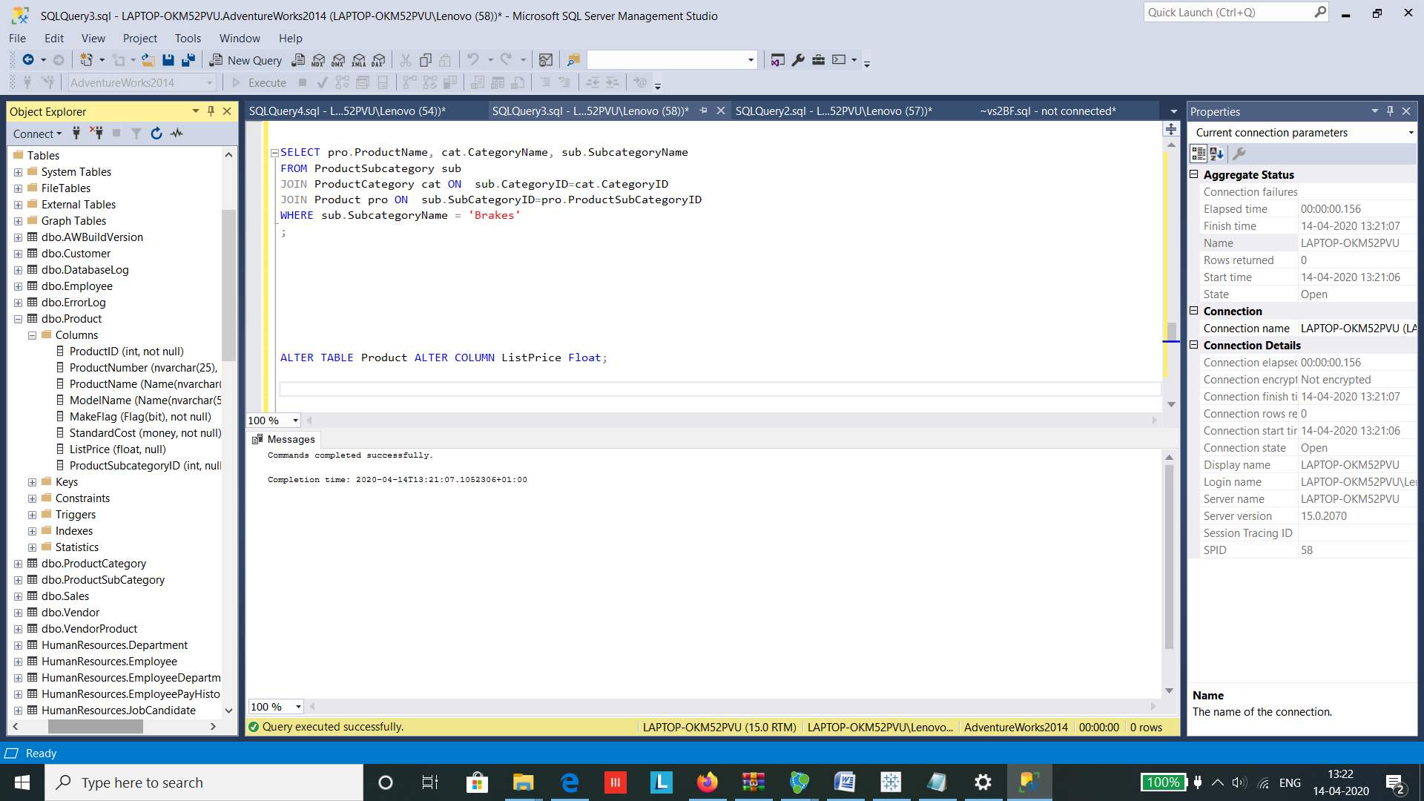

In CQL , we use the SET query to change the datatype followed by toFloat in this case to set the listPrice to float type.

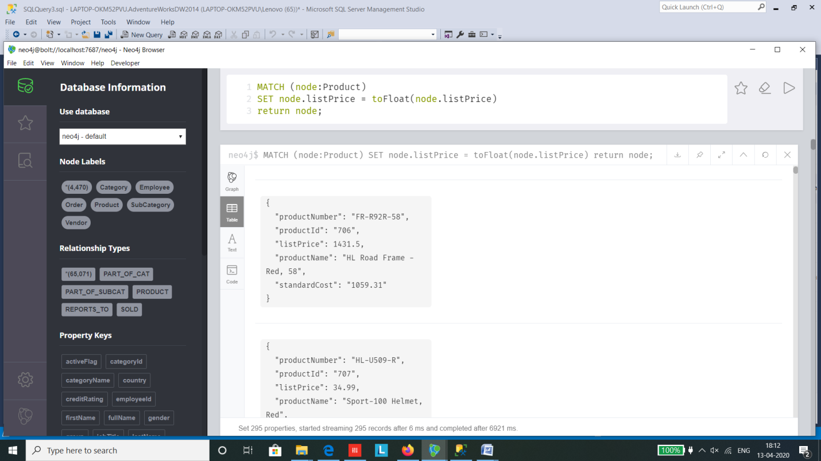

**Query 5 : Like Operator**

In SQL we use the LIKE operator to find similar values to ‘C%’ here it represents that the value starts with C

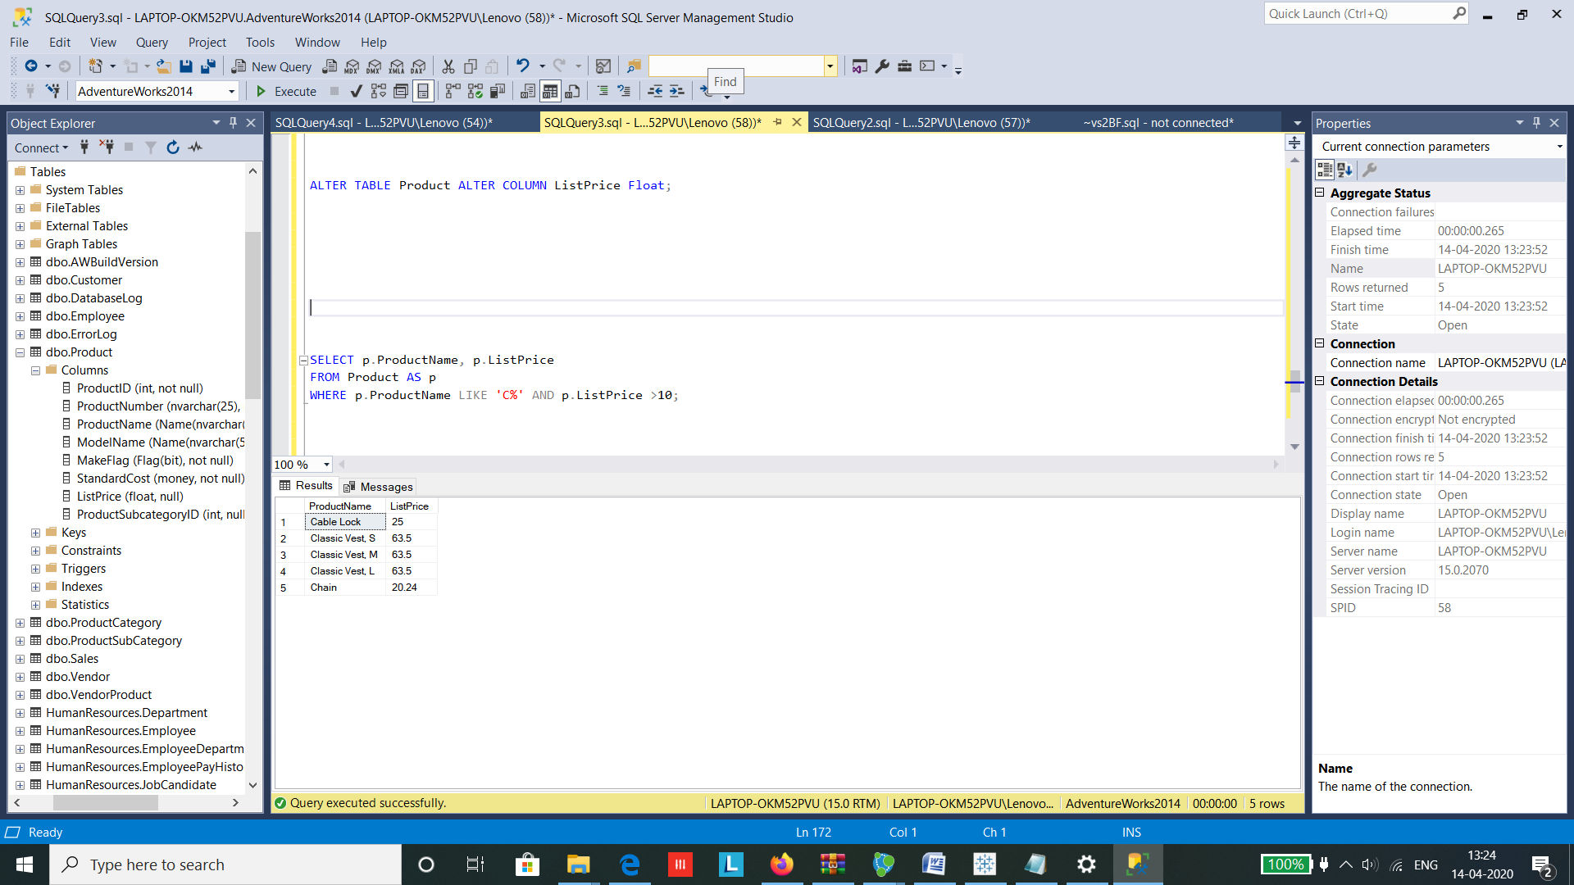

While in Neo4j CQL the STARTS WITH statement is used to find the similar values that start with the letter C.

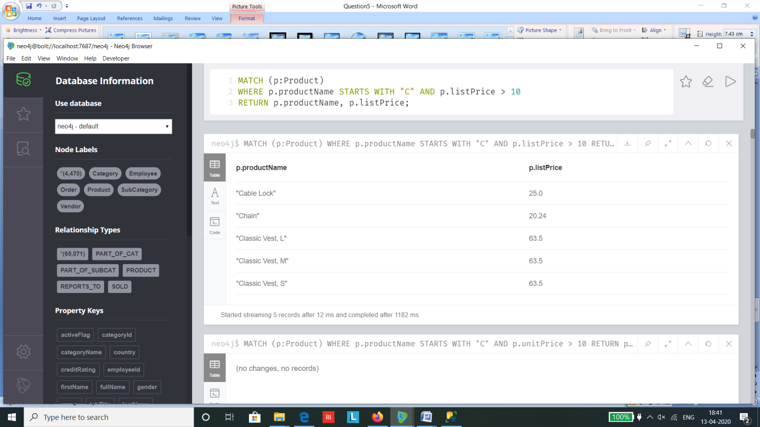

**Query 6 : Aggregation**

Aggregation functions such as min, max, count etc can be performed on both SQL as well as CQL.

But in SQL we have explicitly used the GROUP BY clause to group the output according the column EmployeeKey.

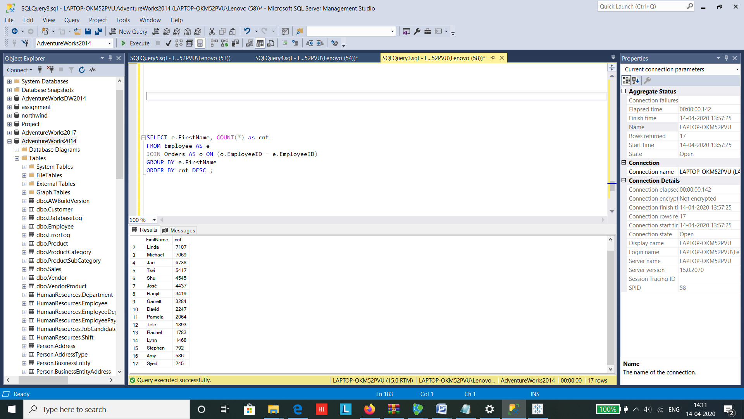

Where as in CQL, there is an implicit grouping Non-aggregated columns automatically group as soon as one aggregeated column is used

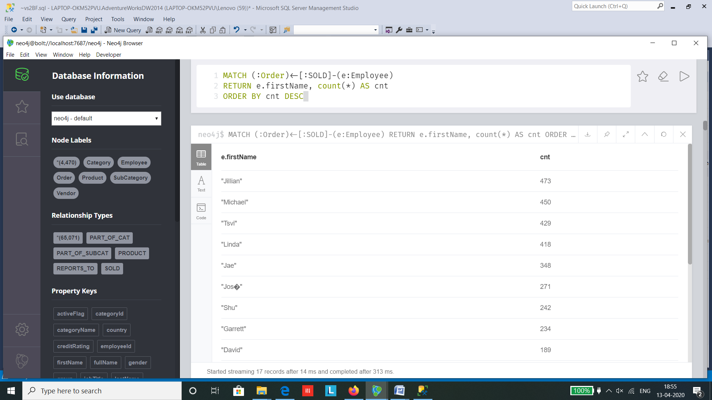

**Query 7: Self Join**

In order to find which employee reports to which manager, in SQL we use a self join in which the table is joined with itself on different parameter lying in the same table for which we create 2 aliases of the same table for reference.

See Appendix for import code

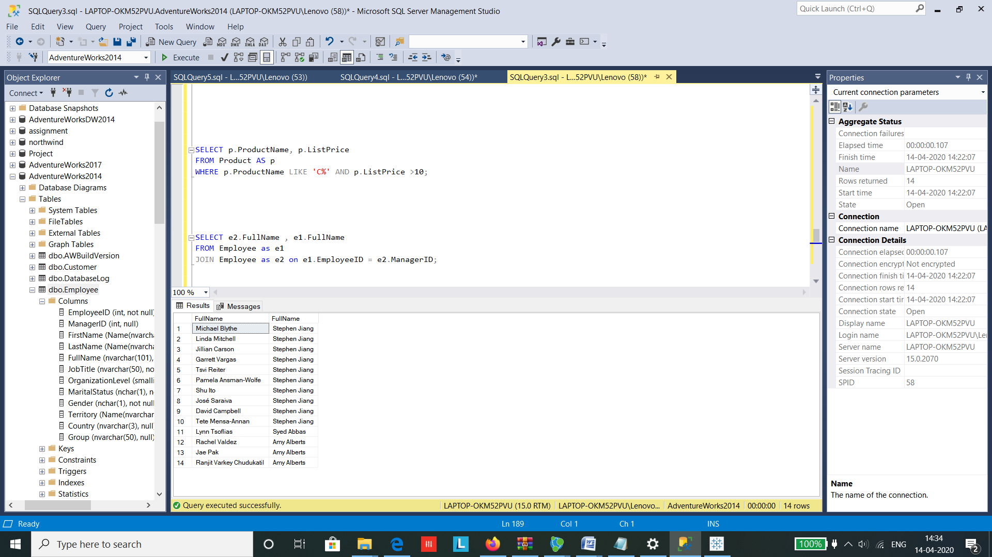

In Cypher the same can be achieved by using the MATCH statement to map the table at different attributes and create a relationship among the two using the MERGE same.

|  |
| --- |
| *MATCH (employee:Employee {employeeId: row.EmployeeID})* |
|  |

|  |
| --- |
| *MATCH (manager:Employee {employeeId: row.ManagerID})* |
|  |

*MERGE (employee)-[:REPORTS_TO]->(manager);*

The following relationship can be used to perform self-join equivalent cypher query:

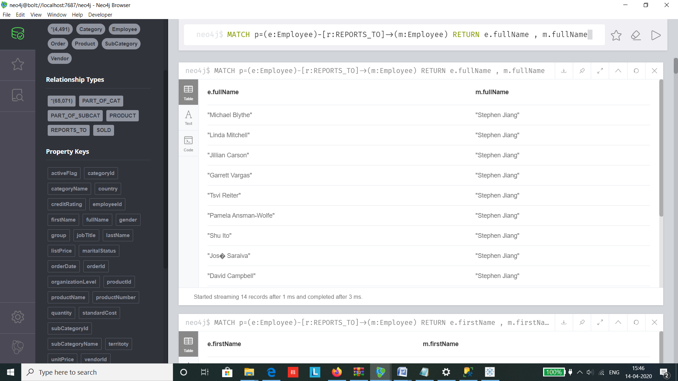

# 6. Conclusions

* We have used relational and dimensional modelling to design a data warehouse.
* We fetched the data and moved it across the data warehouse tables using ETL and we used SQL queries to insert data into the fact table and dimensions.
* We have used different types of visualization using SSRS package and Tableau.
* We used Neo4j to create graphical databases and created relations between them.

# 7. Bibliography

Data Source: <https://www.dofactory.com/sql/sample-database>

For ETL:

SQL Server: <https://docs.microsoft.com/en-us/sql/ssms/download-sql-server-management-studio-ssms?view=sql-server-ver15>

[Accessed 13 April 2020]

Studied through ZagiSales Example on Moodle: <https://elearning.dbs.ie/mod/folder/view.php?id=853499>

ERD and StarSchema: <https://app.diagrams.net/>

<https://epublications.marquette.edu/cgi/viewcontent.cgi?article=1118&context=theses_open>

Microsoft.com. (2017). *Download Microsoft SQL Server 2017 Reporting Services from Official Microsoft Download Center*. [online] Available at: https://www.microsoft.com/en-us/download/confirmation.aspx?id=55252

Neo4j Graph Database Platform. (2017). *Neo4j Graph Platform – The Leader in Graph Databases*. [online] Available at: https://neo4j.com/ [Accessed April 13,2020].

# Appendix A – REPORT CodeS

**SSRS Query :**

**Report 1**

SELECT TOP (10) Product_Dim.ProductName, SUM(Club_Fact.TotalAmount) AS Total_Cost

FROM Club_Fact INNER JOIN

Product_Dim ON Club_Fact.ProductKey = Product_Dim.ProductKey

GROUP BY Product_Dim.ProductName

ORDER BY Total_Cost DESC

**Report 2**

SELECT Product_Dim.ProductName,Customer_Dim.Country, SUM(Club_Fact.TotalAmount) AS Total_Cost

FROM Club_Fact INNER JOIN

Customer_Dim ON Club_Fact.CustomerKey = Customer_Dim.CustomerKey INNER JOIN

Product_Dim ON Club_Fact.ProductKey = Product_Dim.ProductKey

WHERE Product_Dim.ProductName = 'Alice Mutton'

GROUP BY Product_Dim.ProductName, Customer_Dim.Country

**Report 3**

SELECT Product_Dim.ProductName, Calendar_Dim.Month_, SUM(Club_Fact.Quantity) AS Total_Quantity

FROM Club_Fact INNER JOIN

Product_Dim ON Club_Fact.ProductKey = Product_Dim.ProductKey INNER JOIN

Calendar_Dim ON Club_Fact.CalendarKey = Calendar_Dim.CalendarKey

WHERE Product_Dim.ProductName = 'Chai'

GROUP BY Calendar_Dim.Month_ , Product_Dim.ProductName

ORDER BY Calendar_Dim.Month_

**Report 4**

SELECT Product_Dim.ProductName, SUM(Club_Fact.Quantity * Club_Fact.UnitPrice) AS Product_Value

FROM Product_Dim INNER JOIN

Club_Fact ON Product_Dim.ProductKey = Club_Fact.ProductKey

WHERE Product_Dim.ProductName IN ('Alice Mutton', 'Aniseed Syrup' ,'Boston Crab Meat','Camembert Pierrot','Carnarvon Tigers','Chai', 'Chang','Chartreuse verte')

GROUP BY Product_Dim.ProductName

ORDER BY Product_Dim.ProductName

# Appendix B – Neo 4J code

**NEO4J IMPORT CODE**

// Create products

USING PERIODIC COMMIT

LOAD CSV WITH HEADERS FROM "file:///AdventureWorks/products.csv" as row

CREATE (:Product {productName: row.ProductName, productNumber: row.ProductNumber, productId: row.ProductID, modelName: row.ProductModelName, standardCost: row.StandardCost, listPrice: row.ListPrice});

CREATE CONSTRAINT ON (p:Product) ASSERT p.productId IS UNIQUE;

// Create vendors

USING PERIODIC COMMIT

LOAD CSV WITH HEADERS FROM "file:///AdventureWorks/vendors.csv" as row

CREATE (:Vendor {vendorName: row.VendorName, vendorNumber: row.AccountNumber, vendorId: row.VendorID, creditRating: row.CreditRating, activeFlag: row.ActiveFlag});

CREATE CONSTRAINT ON (v:Vendor) ASSERT v.vendorId IS UNIQUE;

// Create employees

USING PERIODIC COMMIT

LOAD CSV WITH HEADERS FROM "file:///AdventureWorks/employees.csv" as row

CREATE (:Employee {firstName: row.FirstName, lastName: row.LastName, fullName: row.FullName, employeeId: row.EmployeeID, jobTitle: row.JobTitle, organizationLevel: row.OrganizationLevel, maritalStatus: row.MaritalStatus, gender: row.Gender, territoty: row.Territory, country: row.Country, group: row.Group});

CREATE CONSTRAINT ON (e:Employee) ASSERT e.employeeId IS UNIQUE;

// Create customers

USING PERIODIC COMMIT

LOAD CSV WITH HEADERS FROM "file:///AdventureWorks/customers.csv" as row

CREATE (:Customer {firstName: row.FirstName, lastName: row.LastName, fullName: row.FullName, customerId: row.CustomerID});

CREATE CONSTRAINT ON (c:Customer) ASSERT c.customerId IS UNIQUE;

// Create categories

USING PERIODIC COMMIT

LOAD CSV WITH HEADERS FROM "file:///AdventureWorks/productcategories.csv" as row

CREATE (:Category {categoryName: row.CategoryName, categoryId: row.CategoryID});

CREATE CONSTRAINT ON (c:Category) ASSERT c.categoryId IS UNIQUE;

// Create sub-categories

USING PERIODIC COMMIT

LOAD CSV WITH HEADERS FROM "file:///AdventureWorks/productsubcategories.csv" as row

CREATE (:SubCategory {subCategoryName: row.SubCategoryName, subCategoryId: row.SubCategoryID});

CREATE CONSTRAINT ON (s:SubCategory) ASSERT s.subCategoryId IS UNIQUE;

// Prepare orders

USING PERIODIC COMMIT

LOAD CSV WITH HEADERS FROM "file:///AdventureWorks/orders.csv" AS row

MERGE (order:Order {orderId: row.SalesOrderID}) ON CREATE SET order.orderDate = row.OrderDate;

CREATE CONSTRAINT ON (o:Order) ASSERT o.orderId IS UNIQUE;

// Create relationships: Order to Product

USING PERIODIC COMMIT

LOAD CSV WITH HEADERS FROM "file:///AdventureWorks/orders.csv" AS row

MATCH (order:Order {orderId: row.SalesOrderID})

MATCH (product:Product {productId: row.ProductID})

MERGE (order)-[pu:PRODUCT]->(product)

ON CREATE SET pu.unitPrice = toFloat(row.UnitPrice), pu.quantity = toFloat(row.OrderQty);

// Create relationships: Order to Employee

USING PERIODIC COMMIT

LOAD CSV WITH HEADERS FROM "file:///AdventureWorks/orders.csv" AS row

MATCH (order:Order {orderId: row.SalesOrderID})

MATCH (employee:Employee {employeeId: row.EmployeeID})

MERGE (employee)-[:SOLD]->(order);

// Create relationships: Order to Customer

USING PERIODIC COMMIT

LOAD CSV WITH HEADERS FROM "file:///AdventureWorks/orders.csv" AS row

MATCH (order:Order {orderId: row.SalesOrderID})

MATCH (customer:Customer {customerId: row.CustomerID})

MERGE (customer)-[:PURCHASED]->(order);

// Create relationships: Product to Vendor

USING PERIODIC COMMIT

LOAD CSV WITH HEADERS FROM "file:///AdventureWorks/vendorproduct.csv" AS row

MATCH (product:Product {productId: row.ProductID})

MATCH (vendor:Vendor {vendorId: row.VendorID})

MERGE (vendor)-[:SUPPLIES]->(product);

// Create relationships: Product to SubCategory

USING PERIODIC COMMIT

LOAD CSV WITH HEADERS FROM "file:///AdventureWorks/products.csv" AS row

MATCH (product:Product {productId: row.ProductID})

MATCH (subcategory:SubCategory {subCategoryId: row.SubCategoryID})

MERGE (product)-[:PART_OF_SUBCAT]->(subcategory);

// Create relationships: SubCategory to Category

USING PERIODIC COMMIT

LOAD CSV WITH HEADERS FROM "file:///AdventureWorks/productsubcategories.csv" AS row

MATCH (subcategory:SubCategory {subCategoryId: row.SubCategoryID})

MATCH (category:Category {categoryId: row.CategoryID})

MERGE (subcategory)-[:PART_OF_CAT]->(category);

// Create relationship for employee reporting structure

USING PERIODIC COMMIT

LOAD CSV WITH HEADERS FROM "file:///AdventureWorks/employees.csv" AS row

MATCH (employee:Employee {employeeId: row.EmployeeID})

MATCH (manager:Employee {employeeId: row.ManagerID})

MERGE (employee)-[:REPORTS_TO]->(manager);